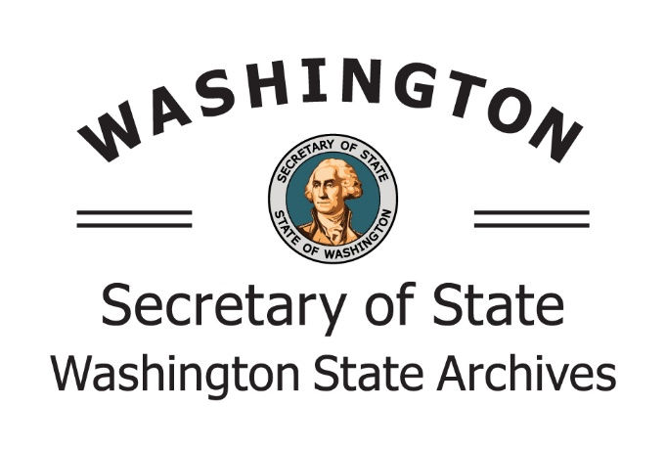

STATE RECORDS CENTER

7590 New Market St.

Olympia, WA 98504-0239

MS: 40239

Tel: 360.586.0173

recordscenter@sos.wa.gov

## Records Center User Access Request Form

This form is to request an account to request and transmit records with the Records Center. Send the completed form to your Agency Record’s Officer for approval. The Records Center will contact you when processing is complete.

|  |  |  |  |  |
| --- | --- | --- | --- | --- |
| First and Last Name | | Agency OFM No. | Agency Office No. | |
| Agency Name and Acronym | | Office Name | | |
| Mail Stop (CMS) | | Phone Number | | |
| Physical Address | | | | |
| Email Address | | | | |
| Records officer use only  Will this user have access to:  Request Files  Transmit Records | | | | |
| Records Officer Name | Records Officer Approval Signature | | | Date |