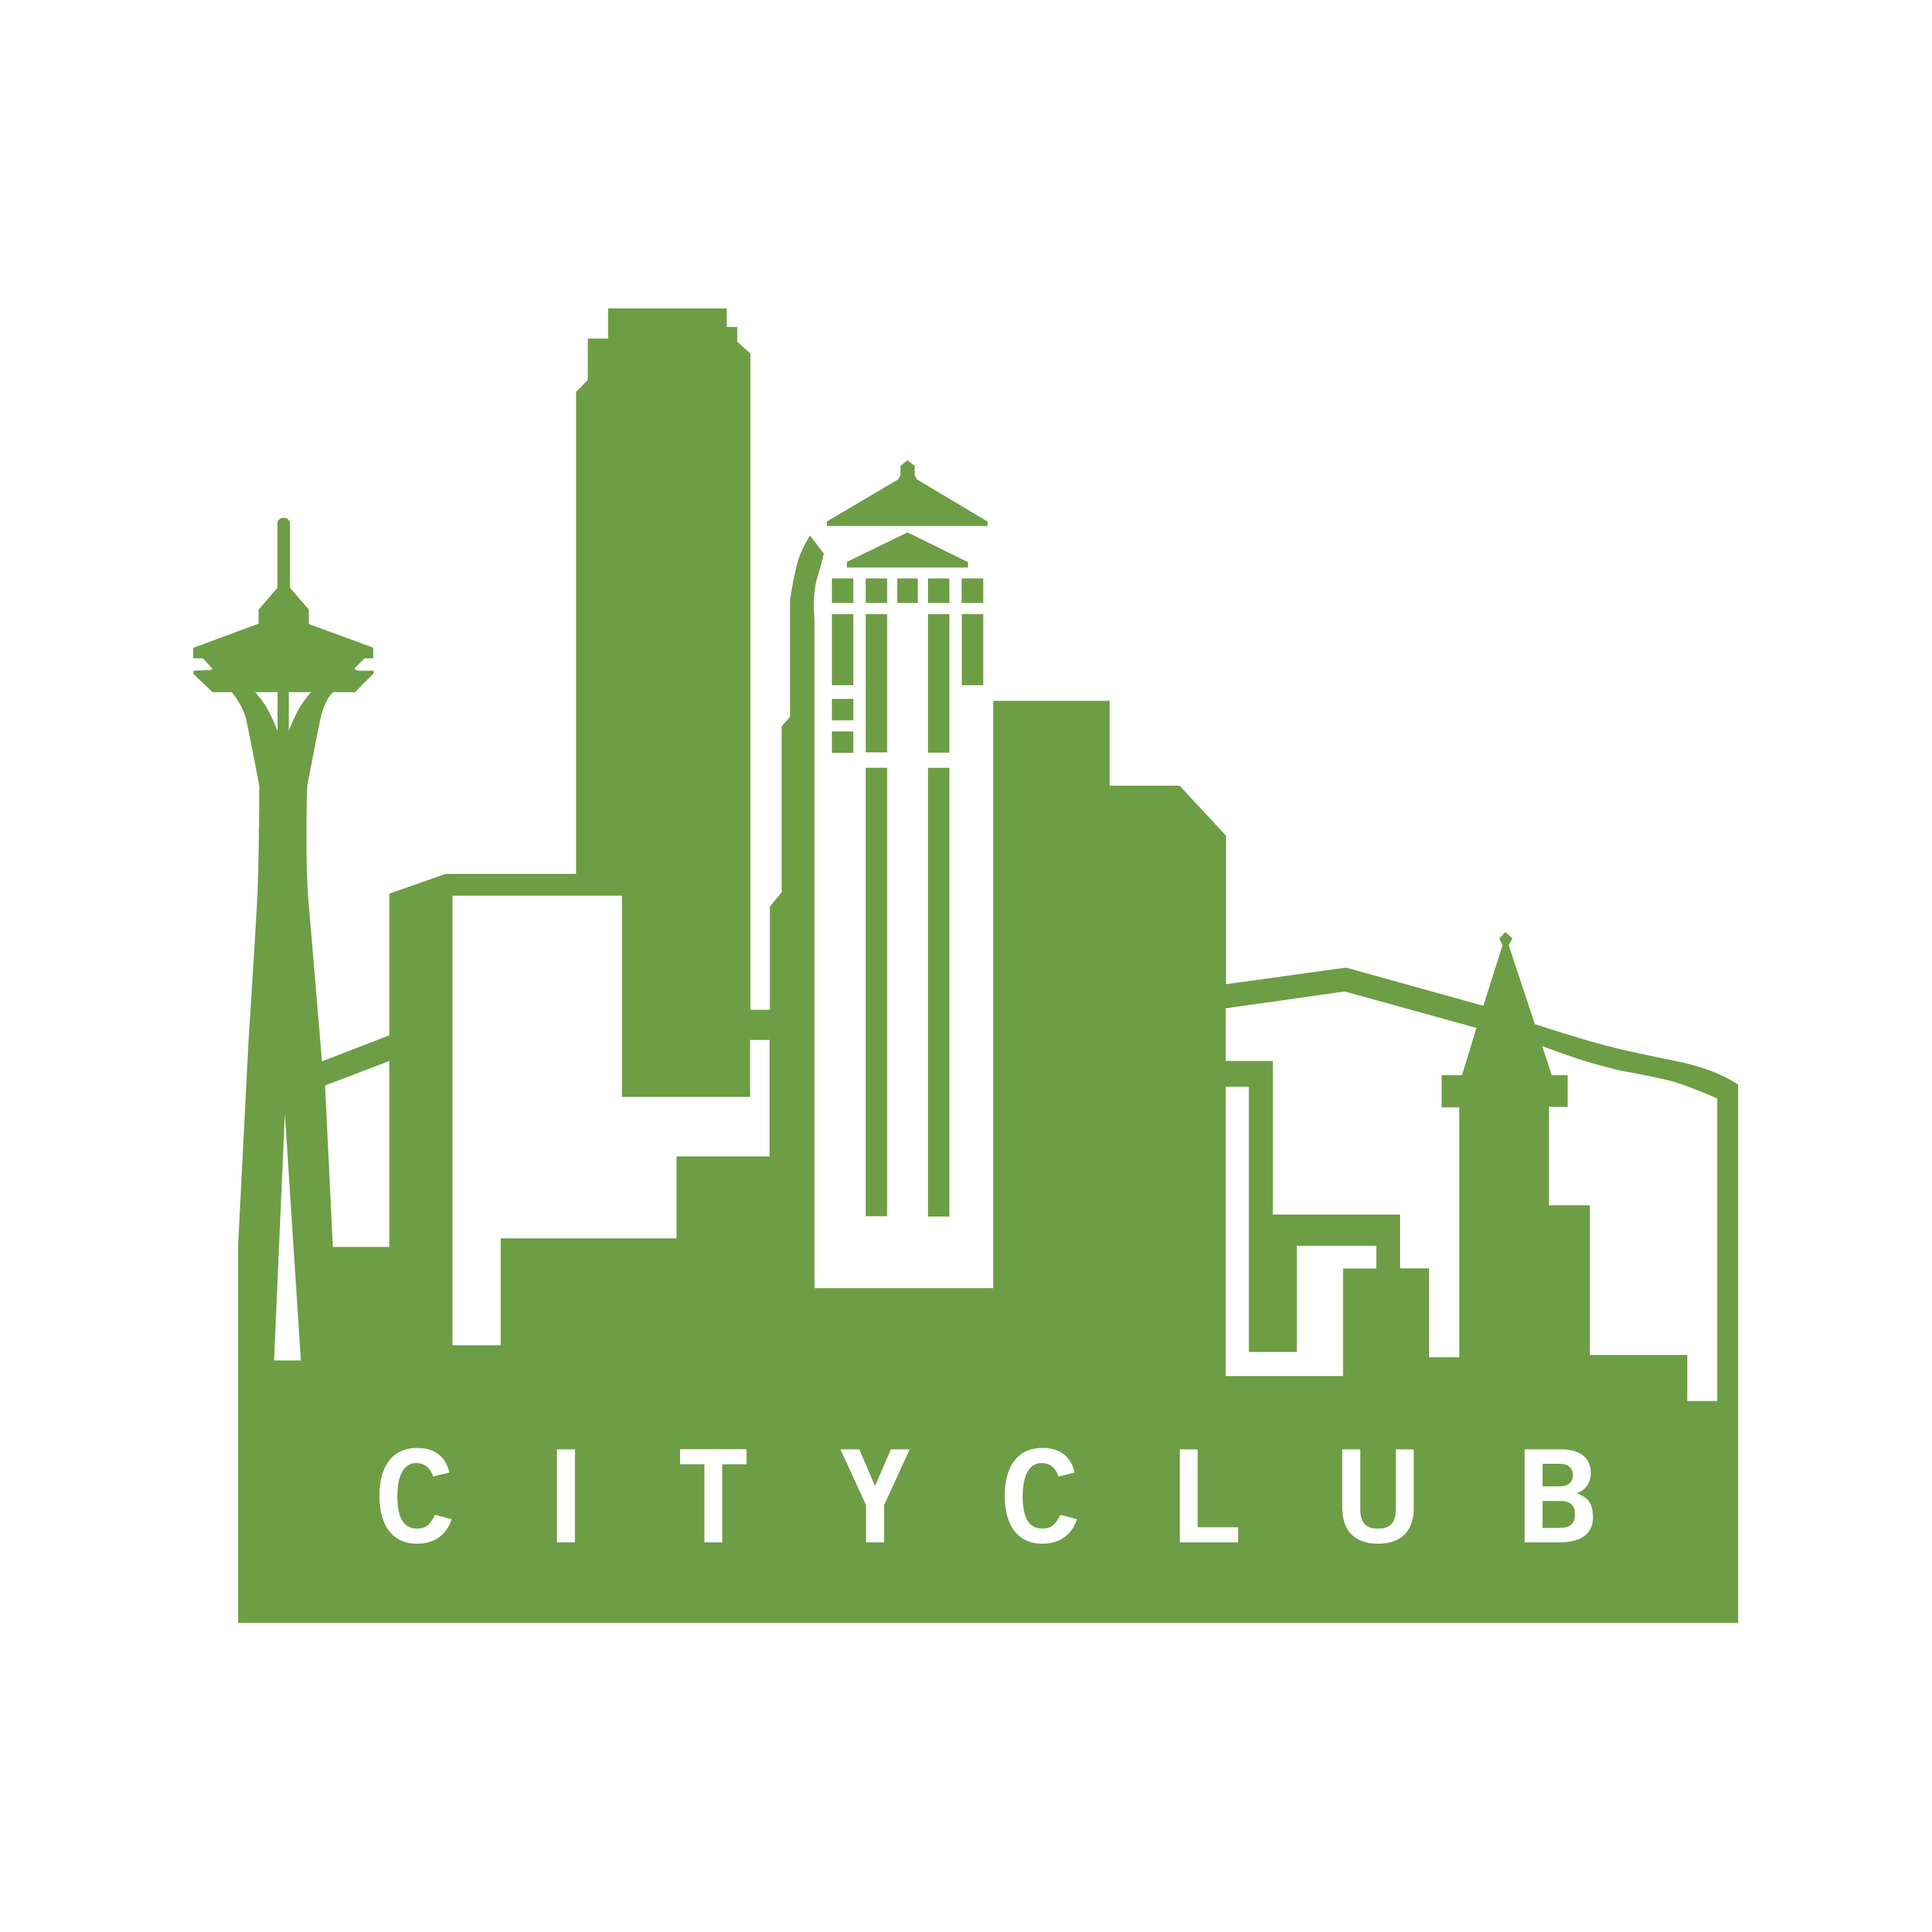

MEDIA RELEASE: October 5, 2011
FOR INFORMATION CONTACT:
Angela Chapman
206-682-7395
achapman@seattlecityclub.org
www.seattlecityclub.org

Launch of the 2011 Living Voters Guide
Washington state’s citizen-powered voters guide
Your forum for the 2011 election

Seattle - Wednesday, October 5, 2011, CityClub, of Seattle, the University of Washington’s Center for Communication & Civic Engagement and its Department of Computer Science and Engineering have collaborated to produce the Living Voters Guide, web-based resource to advance digital democracy in Washington State. With funding from the National Science Foundation, the group developed an online resource to promote community discourse and deliberation on the critical ballot measures before Washington voters this November. This civic technology is inspired by three goals:
- Restoring trust in our neighbors.
- Learning to trust our community’s wisdom.
- Demonstrating trust in Jefferson’s claim that an informed citizenry is the bulwark of a democracy.

New this year, the Living Voters Guide will be available to all Washington voters with county and local measures on tap as well as statewide ones. (Typing in your zip code to the system will let it present the measures relevant for you; for example, residents of Seattle will be invited to weigh in on the pros and cons of the proposed Families and Education Levy.) Our Living Voters Guide invites all Washingtonians to discuss these vital ballot measures together, to explore one another’s positions, and to build a personal, customized platform that will inform their final votes. This voters’ guide is co-created by everyone who participates. It evolves as you and neighbors across our state consider the tradeoffs for each measure. It requires participants who contribute shared points to pledge that they will not make personal attacks on others but focus on the issues before us. It invites everyone to wrestle with both the pros and cons of the ballot measures in a deliberative path toward decision making.

As elections matter more, voters seem to become more frustrated and overwhelmed with the process. And this is not an ordinary “off year election.” The Secretary of State has listed over 35 state, county and local ballot measures. What interests are behind these measures? What are their merits? How best to get involved and make good voting choices? This year voters across Washington have a unique opportunity to share their knowledge, listen to the other side, and contribute their information to the mix. The Living Voters Guide is available online at www.livingvotersguide.org to help people consider their choices and debate the issues with each other in a civil fashion, without the hype and hyperbole of campaign ads and polarizing media talk shows.

ABOUT CITYCLUB: CityClub informs, connects and engages people to evaluate issues through forums and programs that present diverse perspectives and inspire people to get involved in issues that impact our region’s economy and quality of life.
1333 5th Avenue, Suite 24 | Seattle, WA 98101 | 206/682-7395 | www.seattlecityclub.org

# # #

