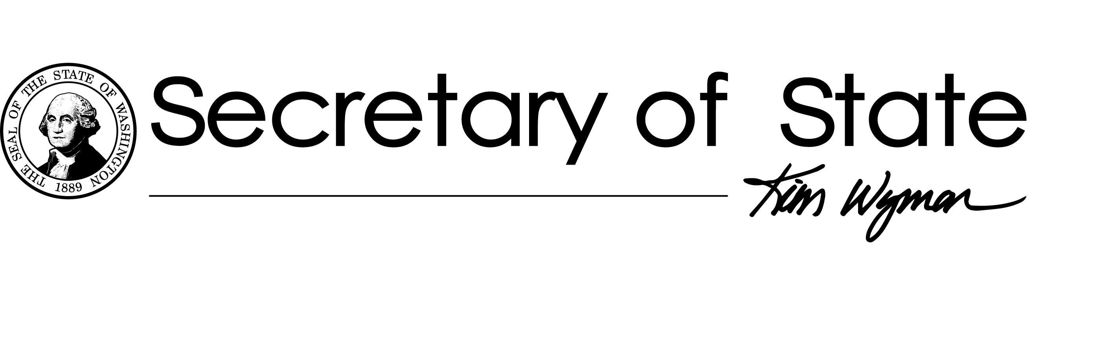

Operations Division
PO Box 40224
Olympia, WA 98504-0224
Fax: 360.236.5044
sos.wa.gov
OSOS Emergency Procurement Report
- An overview of the nature of the emergency including relevant circumstances.
On April 18, 2019, a rooftop humidifier sprung a leak at the Archives building in Cheney, Washington, flooding the Archives’ server racks and destroying storage and servers.
- A description of the threat to the health or safety of individuals, property, or essential state functions if immediate action is not taken to include an estimate of potential material loss or damage.
Because of the rooftop leak, unless immediate action was taken, a collection of irreplaceable data could have been lost. Further, without an immediate solution, the OSOS Archives Division would not have been able to perform its state- mandated function to safeguard government records.
- An account of how the contractor alleviated or eliminated the emergency to include a description of what the consequences would have been if the emergency action had not been taken and the risks associated with inaction.

The rooftop leak presented Archives with the risk of possible failure of the Digital Archive’s primary systems. Had Archives not purchased IT servers for backup storage, an irreplaceable data loss would have occurred.

- A summary of the contractor’s qualifications, experience, and background to provide emergency services and the basis on which this contractor was selected over other qualified firms.

No contractors were involved; IT server hardware was purchased and replaced from a vendor who was able to expedite the order process. The particular brand of server was selected based upon Digital Archives IT staff’s design and engineering.

- Specify the costs, fees, or rates for the purchase.
The cost for 6 servers including sales tax was $75,878.56.
- Please see uploaded Copy of the Emergency Memo signed by Kim Wyman.

