Finding Health Information

You can trust!
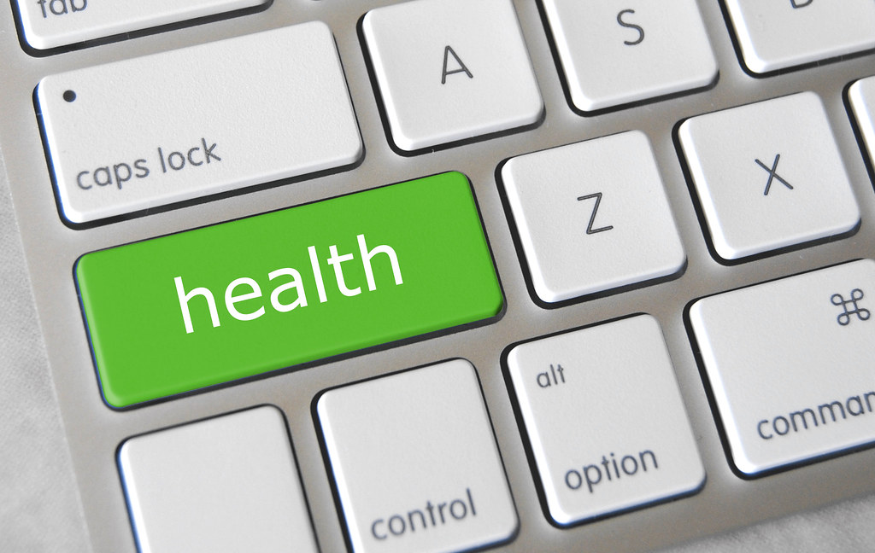
"Health Key" by Got Credit is licensed under CC BY 2.0

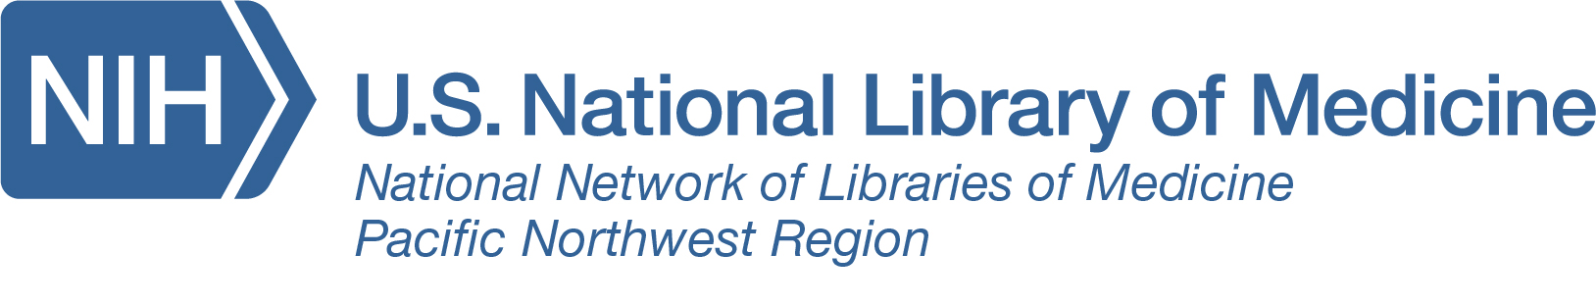

Want to be more engaged in your health?

Join us to learn how to utilize the authoritative and freely available resources from the National Library of Medicine

Wednesday, September 18 at 11:00 a.m.

At the Washington Talking Book & Braille Library

