Washington Talking Book & Braille Library

Administered by the Washington State Library

and Office of the Secretary of State

Reading Matters

Spring 2011

David Junius, Editor

A Message from Danielle Miller, Program Manager

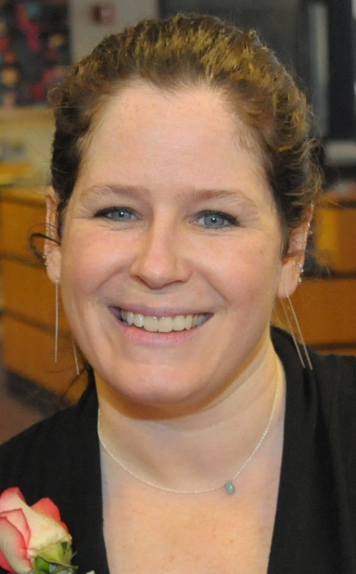
It has been a nail-biting several months as the Legislature has been in session and then in a second session. As I write, the 2011-2013 budget has just been approved. By the time you read this, there will be some concrete information and implications for implementation at WTBBL. But today, I don’t have any real news. Briefly, there will be a cut to the Washington State Library and a portion of that will go to WTBBL. Staff will also take a 3 percent reduction in pay. When I have firm information, I will share it through the WTBBL listserv.
WTBBL was in far worse shape earlier in the legislative session and we were once again helped when WTBBL patrons rallied around us and called on their legislators to oppose a bill that would move us into a “mega-agency” and cut our budget by 22 percent. More than 40 blind and visually impaired people, along with their friends and families, got up early and traveled to Olympia to voice their opposition to the bill. We filled the hearing room and three WTBBL patrons testified on behalf of WTBBL: WTBBL Patron Advisory Council (PAC) member and Washington Council of the Blind (WCB) President Denise Colley, PAC Chair Mike Mello, and National Federation of the Blind of Washington (NFBW) President Mike Freeman.
Never underestimate the power of your advocacy. By early that afternoon, an amendment had been added that removed us from the bill! The WTBBL staff and I are truly appreciative of your support year after year.
Despite the worry and stress of the legislative session, many good things are happening at the library. We continue to try to get a digital player in the hands of every patron and increase access to digital books. If you know someone who could use our service, please tell them – in terms of technology and access, there is no better time to be a patron of the library.
I know many of you are downloading your books from Braille and Audio Reading Download (BARD) and from the WTBBL download site, and I encourage you to see if others in your region could use help with that process. We have new instructions and frequently asked questions (FAQs) on the download page of our website (www.wtbbl.org) for both PC and Mac users. I shifted one of our librarian’s roles to focus on instruction and electronic services so we can do training in person, on the phone, and on the web.
In May, we held our seventh annual Ten-Squared High Tea honoring our patrons who are 100 and older. It was a lovely event with five centenarians attending and two of them being newly inducted into the club. (Currently we have 51 centenarians in all. Wow!) I wanted to bring the theme back to what connects so many of us with our books: the narrator. One of WTBBL’s amazing narrators, Sneha Mathan, spoke about her path to becoming a narrator and voice actor, and shared what it means to her to be the voice of several WTBBL talking books. You can look for Sneha’s books in our online catalog. We had several guests at the tea, including PAC members Mike Mello and Karen Johnson. This is always an inspirational event and we look forward to it every year.
Also in May, I attended the Western Conference of Libraries for the Blind and Physically Handicapped conference in Denver. It is always exciting to get together with the other regional librarians and exchange ideas and support each other. Four representatives from the National Library Service (NLS) attended and they informed us of many exciting changes for the coming year. For example, braille will actually move to BARD and that “B” will finally make sense. Foreign language titles, music materials, and best of all, state-produced digital books will start to go up on BARD, so it can truly be one place for all resources.
I am honored that I was elected Chair of the Western Council for the next two years. A very important part of this role is participating in a monthly call with NLS. I want to be sure to include concerns and ideas from Washington as well as the entire Western Conference Region. I encourage you to contact me with your thoughts and suggestions, or talk to one of our PAC members or WTBBL staff.
Fingers crossed for some sunny news on the budget outcomes and some actual sun!
Get in touch: danielle.miller@sos.wa.gov or (206) 615-1588.

All the best,
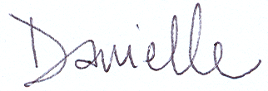
Danielle

2011 Patron Advisory Council (PAC)
The following individuals are current members of the Patron Advisory Council. To reach a PAC member in your area of the state with any questions or ideas you may have, please call David at (206) 615-0417 or (800) 542-0866 for their contact information.
Sue Ammeter (Port Hadlock) - WCB Rep.
Ryan Bondroff (Seattle) - Deaf-Blind Rep.
Norma Jean Campbell (Richland)
Denise Colley (Lacey)
Frank Cuta (Benton City)
Michael Edwards (Fircrest) - Physically Disabled Rep.
Deborah Jenkins (Spokane)
Karen Johnson (Seattle)
Mike Mello (Seattle) - NFBW Rep.
Mary Anna Mohrman (Seattle)
Janice Squires (Kennewick)
Alice Stephenson (University Place) - Veteran Rep.
Emily Stevenson (University Place) - Youth Rep.

The Shipping News by Sally Jo Hagen
New digital books and players keep arriving and a lot of changes have been happening in WTBBL’s shipping department.
Making room for two new inventories means revamping the whole warehouse. Shrinking the space for the cassette books and players to make room for the digital books and players is one of our greatest challenges. We’ll save on space because the digital books are half the size of the cassette books and the digital players are smaller than the old cassette players!
While the digital books take less space, it is taking us awhile to build our inventory to the level of our cassette books. We have roughly 308,000 cassette books in our inventory compared to about 43,000 digital books. The digital collection will continue to grow as the cassettes are phased out.
If you have access to a computer, you can go to our website and download books to a flash drive, then play them on your digital player. For more information, go to www.wtbbl.org, or call one of our reader advisors at (206) 615-0400 or (800) 542-0866.
This summer we will again be participating in youth employment programs from the City of Seattle and the Washington State School for the Blind. They are great partnerships, as are the ones we participate in during the school year with the City of Seattle and the Seattle and Kent school districts. Although these groups are school-age volunteers, we also have a large core of adult volunteers who come through the shipping department.
Volunteers help us with sorting our daily mail, inspecting and shelving returned books, and repairing cassette players. While we absolutely have the best staff in the shipping department with Bonnie, Rick and Marah, I’m sure they would join me in tooting the volunteer horn. In the last five years, our volunteer participation in the shipping department has grown by 56 percent!
There is always something interesting happening and something fun to do in the shipping department at WTBBL!

WTBBL Author Profiles

Anjali Banerjee by Theresa Connolly
Anjali Banerjee recently said in an interview that writing for young people is “writing for everyone.” She explained that she considers the subject matter but does not simplify language or vocabulary. Banerjee feels her books for young people address universal themes and, in that way, are of interest to anyone. I agree.
I recently listened to Maya Running and Looking for Bapu and found myself walking down the street both crying and laughing out loud. In both books, there are smart, quirky young people enjoying secure family lives. They also struggle mightily with problems that arise.
Both Maya in Maya Running and Anu in Looking for Bapu suffer prejudice and bullying because of their darker skin. Maya feels the anxiety of being in love for the first time and jealousy when her exotic cousin arrives from India and overshadows her. Anu’s heart breaks when Bapu, his grandfather and daily companion, dies.
Although Anu says, “I don’t know what to do,” many times, he tries everything he can think of to get his Bapu’s spirit back. He thinks of many things and proceeds with a steely determination until, with the help of others, he finds what works. Along the way, he creates some hilarious, touching scenes.
Anjali Banerjee was born in India and raised in North America. She currently lives in Washington State. This background infuses her books with gods I did not know about, and with beautiful words like sadhu (a holy man), pakora (a battered and fried vegetable snack), and Ganesh (the god with an elephant’s head, “Remover of Obstacles, Granter of Wishes”) that I seldom hear. It also gives me settings that I recognize and places I pass by. Magic mingles with the real world and creativity is rewarded. Contact WTBBL if you would like to hear her books or read them in braille. Here is a list of what is available:
In digital audio (on cartridge and as a download) for younger readers: Maya Running (DBW07767), Looking for Bapu (DBW08050), and Seaglass Summer (DB71452); for adults (on cartridge and as a download): Invisible Lives (DBW08150) and Haunting Jasmine (in process, DBW08309).
In braille for younger readers: Looking for Bapu (BRW01311), and for adults: Invisible Lives (BRW01309).
For more information about Anjali Banerjee, have a look at her website at www.anjalibanerjee.com.
Happy reading!

Lauren Willig by Eura Ryan Szuwalski
Lauren Willig is a New York Times bestselling historical romance author whose series, The Pink Carnation, is filled with comedy, espionage, adventure and, of course, romance.
Each of Willig’s novels is really two stories in one. One storyline is set in modern-day London, while the majority of the chapters focus on a heroine in 19th century England or France. The modern-day protagonist, Eloise Kelly, is an American graduate student studying in London and working on her dissertation with the assistance of an Englishman, Colin, who has spies in his family tree. Eloise’s story and romance with her Englishman are background to the main tale of spies battling Napoleon’s campaigns in France and England.
The 19th century protagonist changes with each book, as does the fictional, flower-inspired spy. Start with the first book in the series, The Secret History of the Pink Carnation, which takes the reader on a path with Eloise to discover the real person behind the Pink Carnation, as our 19th century heroine, Amy Balcourt, is searching for love behind the mask of the Purple Gentian, another spy.
Mixing fictional and historical characters, Willig creates a highly amusing story. Like Eloise, Willig spent time in London during her graduate years. Educated at Yale, Willig has also spent time at her alma mater teaching the study of historical romances. Willig brings a detailed eye to the genre and tells a story that keeps you wanting more. Whether you’re following Eloise or the 19th century heroine, you’ll stay entertained and fall in love with each character.

Here are the titles available at WTBBL:
#1, The Secret History of the Pink Carnation is available in large print (LP 21525), on cassette (RC 60668) and on BARD as a downloadable book (DB 60668).

#2, The Masque of the Black Tulip is available on cassette (RC 61532) and on BARD as a downloadable book (DB 61532).

#3, The Deception of the Emerald Ring is available on cassette (RC 64654) and on BARD as a downloadable book (DB 64654).

#4, The Seduction of the Crimson Rose is available on cassette (RC 67186), on a digital cartridge and on BARD (DB 67186).

#5, The Temptation of the Night Jasmine is available on cassette (RC 68860), on digital cartridge and on BARD (DB 68860).

#6, The Betrayal of the Blood Lily is available as a digital cartridge and for download on BARD (DB 70769).

Volunteer Spotlight: Rachel Glass
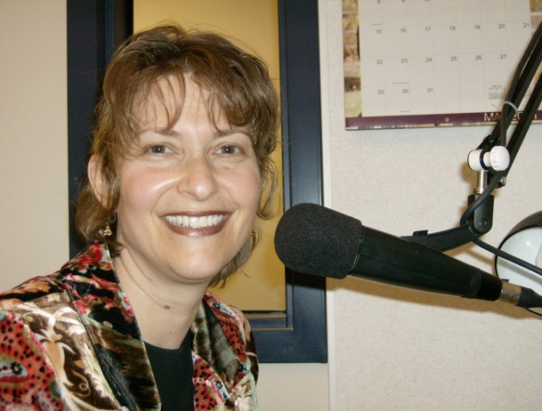
Rachel has been volunteering at the Washington Talking Book & Braille Library since 2006 and has worn many hats for WTBBL’s Evergreen Radio Reading Service (ERRS). Her first job was reading the Eastern Washington news and soon she became the host of “Parent Time.”
Rachel currently records audio books at WTBBL. You can also hear Rachel as one of the hosts of the “Literary News” program, where she has interviewed dozens of authors, including Ron Reagan, Louis Sachar, Andre Dubus, Jane Smiley, Kate DiCamillo and Lisa See.
When not volunteering, Rachel works as a professional actress on stage, in film and television, and doing voice work. You can hear her every week on the KOMO News radio Sunday morning team, as well as on KIXI-AM as a regular on Jim French’s “Imagination Theatre.” Her favorite movie role featured her opposite Sharon Stone in the film Last Dance where she was bludgeoned to death with a crowbar by Ms. Stone.
Rachel grew up in Hawaii and has lived in the San Francisco Bay Area, Los Angeles and Nashville. She and her husband have shared many adventures together, including being professional artists, traveling across the country in a U-Haul, standing on a shelf of rock while looking down into a molten lava flow of an active volcano, surviving three major earthquakes (including Seattle’s in 2001), facing down a tornado, and witnessing out of their apartment window the mayhem of the 1992 Los Angeles riots.
Currently Rachel resides in Seattle with her husband and daughter.

Meet Our Staff: Bonnie Brown and Steve Goettsch

Bonnie Brown
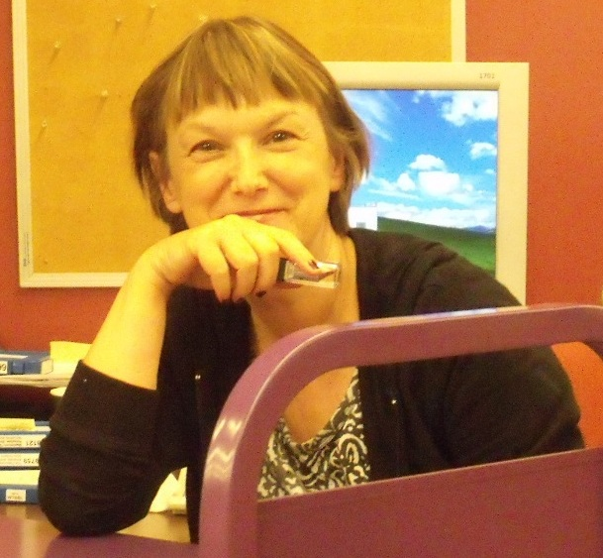
It all started in high school. I couldn’t get into Drama because the class was full, so I ended up in a radio class. We did radio drama and a local station aired our shows on Sunday nights. That’s when I knew I wanted to be in radio! So I became a dental assistant. I thought I would do that until I got married…maybe three or four years. Thirteen years later, I finally met my Tom and we were married. I thought I would just enjoy being a housewife for a while since I had waited so long.
After several months, I realized there had to be more than making meals and cleaning house. About that time I received a brochure in the mail about volunteering at the Talking Book & Braille Library. I became a book narrator and loved it. I then began working part-time in the Taping Department.
One night after work I was in the break room waiting until it was time to go to a “How to Get Started in Radio” class when my supervisor saw me and found out I was interested in radio. She asked if I would like to be trained to be a broadcaster for the ERRS. Would I?!?! Eventually, I went to Bellevue Community College and enrolled in its radio program.
I taught radio labs and worked at KBCS-FM, the station on campus, and hosted a jazz show. Later, I became a traffic reporter at Metro Networks. My shift was working the morning drive on KUOW-FM, KIXI-AM, and KTTH-AM. It was my high school dream come true! I was a traffic reporter for 10 years.
Now I’m back at WTBBL, but this time in the Shipping Department. I’m part of the team that gets the books and equipment out to you. From time to time, you’ll also hear me on the ERRS interviewing authors on “Literary News.”
It’s wonderful to be here after all this time!

Steve Goettsch
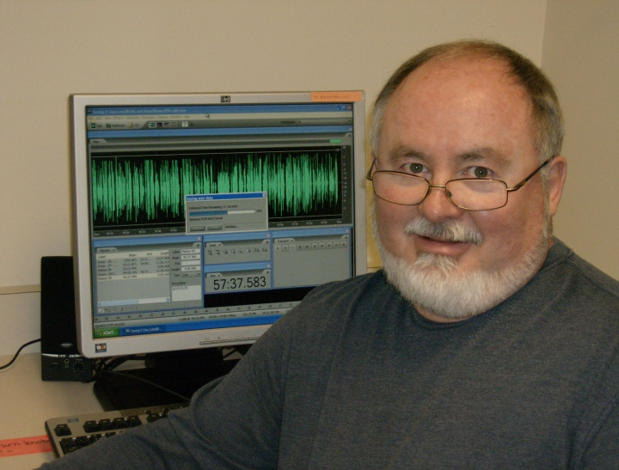
Hello, library patrons. I am the Audio Production Technician here at WTBBL. I produce the locally narrated audio books and download requested NLS books for digital cartridge. I also edit local books in post-production and make extra copies of high-demand audio books.
My other duties include processing material requests from other NLS libraries across the nation and supervising volunteers who process recorded books needing repair.
I am originally from Des Moines, Iowa, where I was involved with music for many years, playing trombone with various organizations from classical to jazz to rock. In the mid-1970s, I managed a popular record store and in 1979, decided to move to the Great Northwest with my future wife.
I started as a volunteer at WTBBL in the early 1980s and later became part of the staff. As I remember, nearly half of the recorded books at that time were on rigid or flexible discs played on record players. The new digital players represent big advances in the quality of sound and the ease of operation.
It’s great to be at WTBBL and to serve our wonderful patrons!

Radio-Activity by John Pai, Lead ERRS Broadcaster
You may have noticed that our radio broadcasts have been free of interruptions and stronger in technical consistency. With the switch over to the WireReady Radio automation software and the Adobe Audition production software, along with new computers, we have been enjoying the fruits of the newest technology in radio service.
The transition was time-consuming, but now that we have completed the training of the entire radio volunteer staff, fellow ERRS broadcaster Gregg Porter and I have been able to concentrate on training new volunteers, developing new talk and literary news programs, and upgrading content material delivery for our broadcasts.
One of the new elements we’ve added is having our current grocery ad and shopping news programs available to listen to on-demand or download as a podcast. You won’t miss any store specials and you can even take the program along with you as you shop.
We also have the current week’s talk show and literary news programs available for on-demand listening, as well as special programs from the “Science Fiction Hour” and the “Kitchen Corner.” Look for even more additions to this service in the future.
You may have also noticed several new voices on the air. A new crew of exceptional volunteers is working on programs from the news to comedy, travel and health.
A voice you have been hearing daily has been that of Barbara Longo, who has just completed producing 366 individual episodes of “This Day in Music History.”
We also would like to bid a fond adieu and a thousand-fold thanks to longtime volunteer Beth Weir. She has retired from her duties on the “Sunday Funnies” as well as “Kids Time.” Listen for her voice in the future, though, as she’s not going very far away.
We also say “so long” to 15-year volunteer Mary Schile, who has voiced Time magazine as well as Rolling Stone. “Harmonic Convergence” host Bill Barton will be on hiatus while morning news host Phil Lipe and “Puget Sound News” host Meredith D’Amore will be leaving in July.

Authors paying us a visit on our “Literary News” program in the last few months include:
Ron Reagan (My Father at 100)
Deborah Rodriguez (A Cup of Friendship)
Deborah Harkness (A Discovery of Witches)
Patrick Rothfus (The Wise Man’s Fear)
Patricia Briggs (River Marked)
Chiwan Choi (The Flood)
Andre Dubus III (Townie: A Memoir)
Dr. Michael Riera (Staying Connected to Your Teenager)
Paula McLain (The Paris Wife)
Michio Kaku (Physics of the Future)
Donovan Hohn (Moby-Duck)
Mary Daheim (An Alpine Vengeance)
Nic Sheff (We All Fall Down: Living with Addiction)
Janny Scott (A Singular Woman: the Untold Story of Barack Obama’s Mother)

Listen and look for these interviews in the upcoming months.

As always, we’re evaluating and adjusting our program schedule, especially the programs we get from outside sources. Let us know if you have any thoughts or comments. Drop us an email at radio@sos.wa.gov. We really appreciate hearing from you. Thanks for listening!

NEW Books Available at WTBBL by Herrick Heitman
Here are some of the audio and braille books we have recently produced. These descriptions and the downloadable audio books are added to our website as each book is completed. Digital cartridge copies are available for checkout.

Audio: Adult Fiction
The Alpine Recluse [#18, Emma Lord series] by Mary Daheim.
In the quiet Washington State town of Alpine, newspaper editor Emma Lord is preparing the latest edition, when she learns of an act of arson a block away. Emma abets Sheriff Milo Dodge in the ensuing investigation and it soon becomes clear that the inferno has been used to cover up an even more sinister crime: murder. Can Emma and Milo find the killer before he strikes again? 2006. Narrated by Andrea Lewis. 9 hours, 24 minutes. Digital Book DBW 8212. Also available as a downloadable digital book from WTBBL.

Audio: Adult Nonfiction
Amber Waves and Undertow: Peril, Hope, Sweat, and Downright Nonchalance in Dry Wheat Country by Steve Turner.
Telling stories specific to Columbia Plateau farmers and farmland, this journalist puts the lives and difficulties of individual farmers into national and global contexts. He interweaves family narratives, historical episodes, and his own experience as a young harvest hand to illuminate the transformation of rural America from the 19th to 21st centuries. Narrated by Mary Schlosser. 2009. 7 hours, 6 minutes. Digital Book DBW 8204. Also available as a downloadable digital book from WTBBL, and as Braille Book BRW 1332.

Braille: Adult Fiction
Reservation Blues by Sherman Alexie.
Thomas Builds-the-Fire is an unlikely rock band leader: he is a little goofy looking and is kind and considerate. But he has the guitar of blues great Robert Johnson, and its music compels others to join the group Coyote Springs. The band’s tale includes some wild stories about others in the Spokane tribe and is told with wry humor, mysticism, and warmth. Some strong language and some descriptions of sex. 1995. Five volumes. Braille Book BRW 1340.

Braille: Adult Nonfiction
Edible Heirlooms: Heritage Vegetables for the Maritime Garden by Bill Thorness.
Heirloom vegetables are the older varieties of familiar plants that were in use before World War II. This book tells gardeners in the coastal area from California to Canada which heirloom vegetables will do best and offers historical and cultural techniques to enhance their growing experience. 2009. Three volumes. Braille Book BRW 1345.

WTBBL Giving Update by Carleen Jackson
As we near the end of WTBBL’s fiscal year, it is a joy to be able to thank the hundreds of donors who, through their gifts to the annual fund and calendar and through memorials and bequests, have shown their dedication and support of WTBBL’s mission.
It is also a pleasure to report one way WTBBL has used donor funds to enhance the services that it provides. The Heritage Center Board of Trustees approved $26,000 to purchase additional supplies of digital cartridges and digital book mailing containers. This will allow WTBBL to keep up with increasing demand for digital books. We heard your feedback that “We don’t want to lose our books!” and through your generous donations, we will be better ready to meet demand.
Nearly $5,000 of donor funds were tapped for outreach materials. It is important to keep WTBBL in front of the public. The funds will pay for a wide variety of materials that will let people know about WTBBL services, promote the digital talking book machine, the Evergreen Radio Reading Service, and more. Over the past three years, the supply of these items has diminished and become out of date. With less state support, there is no budget for outreach, so this fills an important gap.
While you know that WTBBL’s staff is already superb, $1,000 supported staff training. It gave library staff the opportunity to keep up-to-date on the latest in customer service, workplace safety and other topics. This dedicated group has not had a training day since 2008! They appreciated getting together and learning new things that will make their work at WTBBL even better.
This is just a sample of how WTBBL donors help this great organization stay great and get even better in serving our patrons. It doesn’t seem enough to just say thanks!
For this year, we are a little behind in our fundraising, so there is still time to make a gift before June 30. If you have not yet donated, please consider doing so. Any amount is appreciated and helps us better serve you. Just send your check to WTBBL, 2021 9th Avenue, Seattle, WA 98121-2783.
To give by credit card, call Carleen Jackson at (360) 902-4126 and we can accept your gift over the phone.

