The Washington State Library has been tasked with studying public library usage patterns during this current period of economic downturn. A quick survey was conducted where we asked for usage statistics for the most recent 6 months compared the same period from the year before. The results were gathered in December, 2008, for the six months running from June through November of 2008. Thirty-six out of a possible total sixty-four Public Libraries in Washington State were included in our Sample Set. Every region of Washington State (East, Central and West) as well as every type of library (Municipal, Rural County, Inter County, Island, and Partial County) is represented in the sample group used.

Since we were asked specifically to consider what impact, if any, a declining economy might have on public library usage across the state, numbers that were substantially influenced by other factors, such as malfunctioning people counters, significant changes in counting methodologies, or extended library closures due to renovation or remodeling, were removed from consideration. Similarly, the data was checked for outliers as a routine part of data analysis using the Grubbs’ Test for Outliers. GraphPad Software’s Outlier calculator, http://www.graphpad.com/quickcalcs/Grubbs1.cfm, was utilized and all outliers identified were removed from the data set.

Usage statistics were collected for the following six library services measures: Attendance (Patron Visits), Circulation (Material Checkouts), Virtual Visits, Reference Transactions, Percentage of Time Public Internet Computers in Use, and Number of Users of Public Internet Computers. Change in usage figures from 2007 to 2008 for the June-November time frame across all service six measures for each responding library were calculated using the formula: ([2008 Value – 2007 Value]/2007 Year) and the average computed for each service category. The results indicate that usage, as measured by the average public library response, was up across all service measures compared to the same period for the previous year. See chart below.

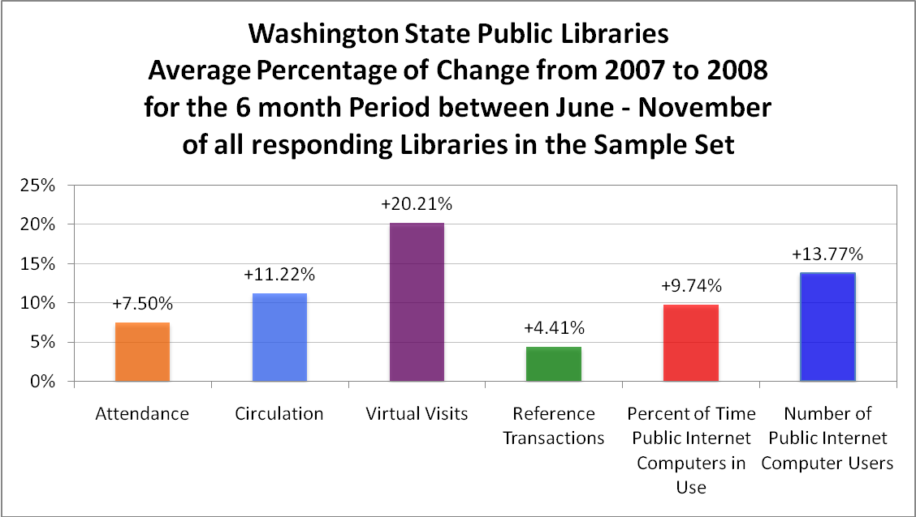

In order to gain a better understanding of the real significance of these usage numbers, we compared them to the percentage increases experienced in each of the previous four years (considering the same service measures and sample set of libraries). When analyzing the data from these earlier years the same techniques were used as were applied to the 6 month 2007-2008 data set. Namely, numbers that were substantially influenced by other factors, such as malfunctioning people counters, significant changes in counting methodologies, or extended library closures due to renovation or remodeling were removed from consideration as were all outliers discovered using the Grubbs’ Test.

Please note that the time frame for the Percentage of Change figure from 2007 to 2008 is June – November, whereas the Percentage of Change figures for all prior periods is based on the full calendar year of January – December.

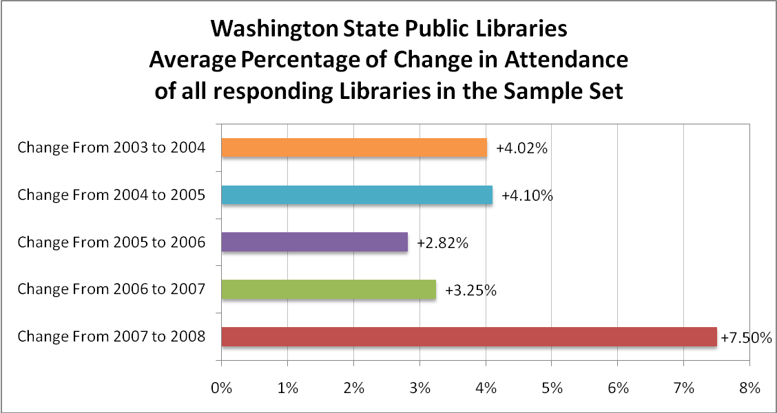
The rate of increase in Attendance for the six months of June-November from 2007 to 2008 is almost double that of the five year average of 4.34%, and is likewise nearly double that of the next largest increase of 4.10% experienced between 2004 and 2005.

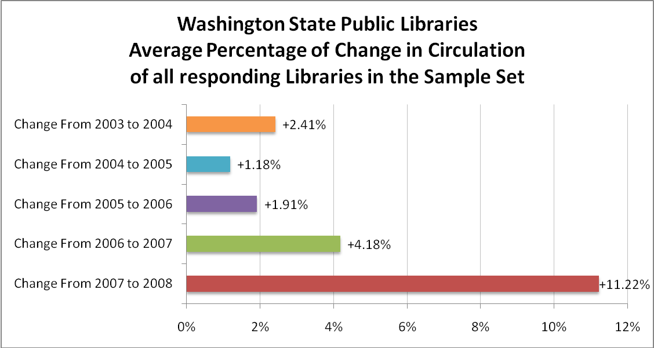
The rate of increase in Circulation, is even more pronounced. Considering the six months of June-November from 2007 to 2008, the growth rate in Circulation was 11.22%, which is greater than the compounded average growth rate of the previous four years combined (10.01%)!
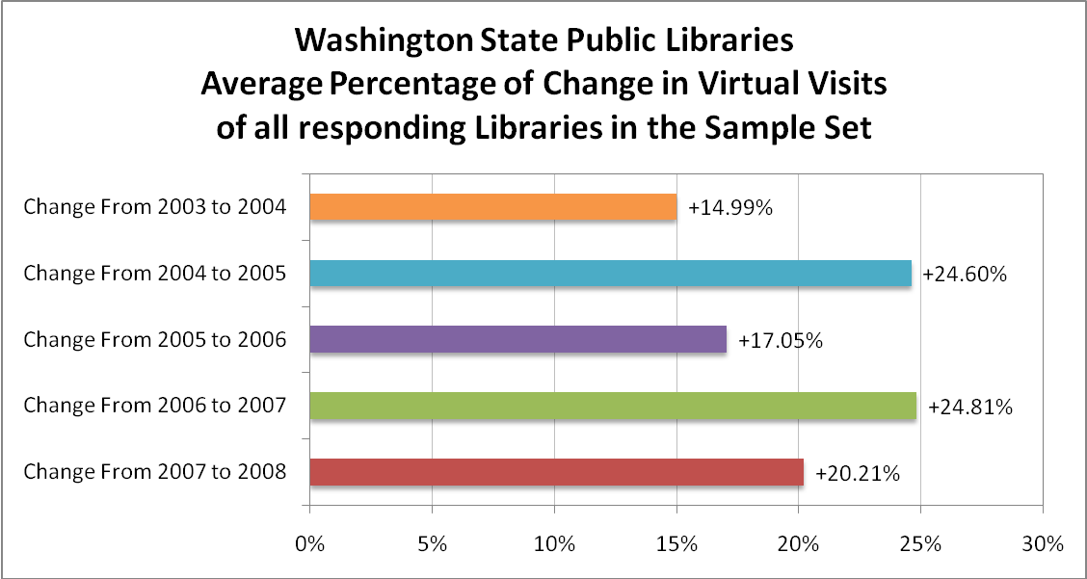
Although not the highest rate of change seen in this five year span, the rate of growth in number of Virtual Visits in 2008 is still over 20% from that of the previous year. In fact, each year shows a growth rate of at least 15% reflecting the incredible explosion of computer and web technologies, interest and use.

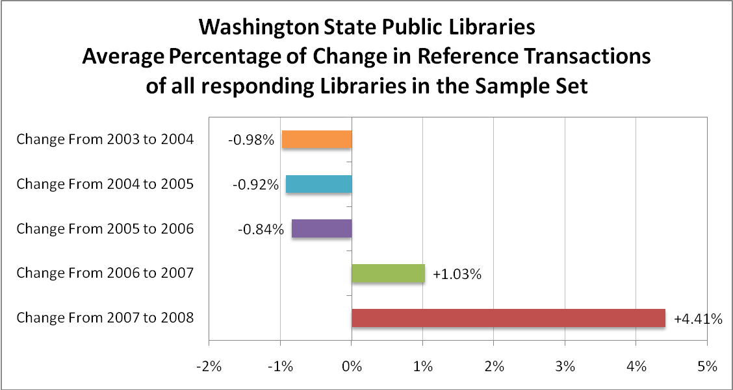

Reference transactions are the only place in this analysis where we see any decreases, although at less than a rate of -1%, the drop offs are modest and might be an indication of the Google effect. The rate of increase in 2007-2008 is 4 times that of any of the previous years in this 5-year span.
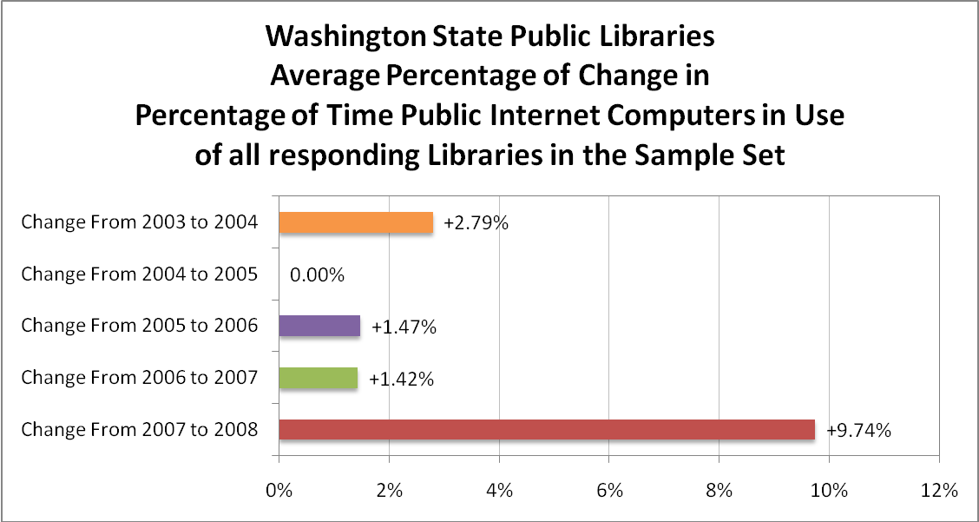
The lower rates of change seen in the earlier years for this service measure are somewhat misleading, given the fact that many internet computers are already in use 100% of the time and that the number of computers increases every year in an attempt to keep up with demand. This makes the rate of change seen in 2008, nearly twice the compounded rate of the previous four years combined, all the more remarkable.

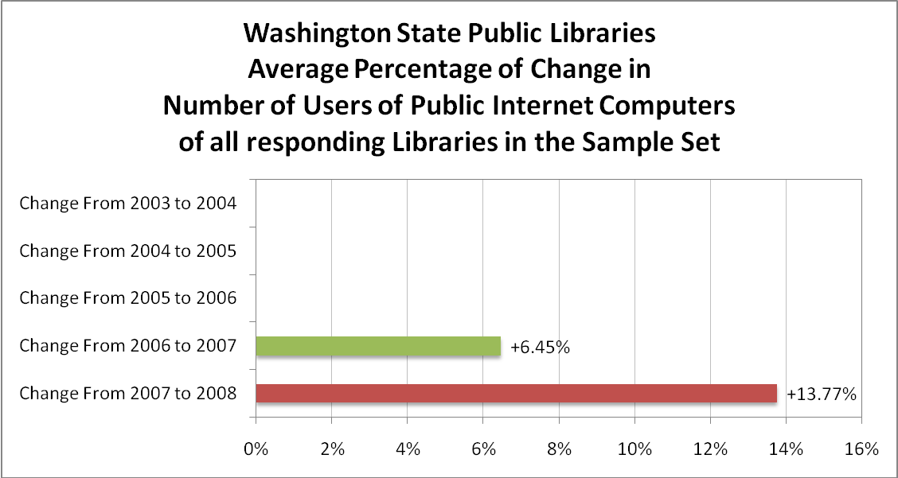

The rate of increase in Number of Internet Computer Users in 2008 is double that of the previous year.

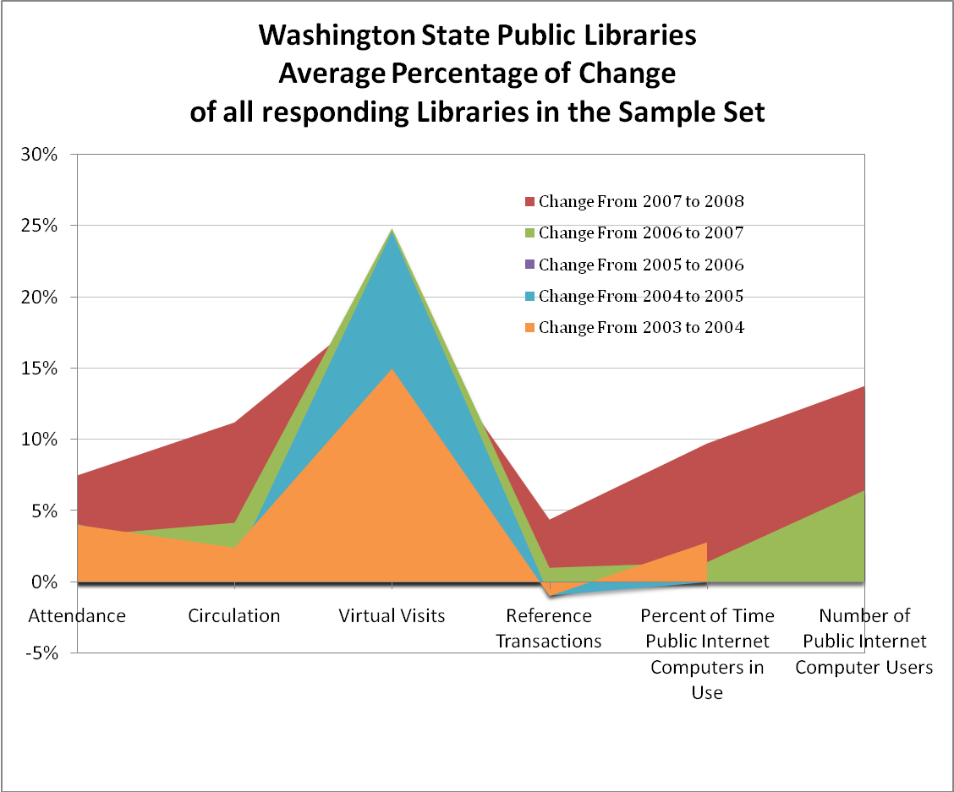

This area chart helps demonstrate the relationship of growth rates seen in 2008, shown in red, compared to the previous four years across all service measures. Successive years follow behind the earlier years and the height of the red, representing growth rates in 2008, above the other colors is an indication of the magnitude of change relative to the other years.

According to The National Bureau of Economic Research (NBER) a private, nonprofit, nonpartisan research organization, founded in 1920, and known for marking the start and end dates of economic downturns, the US economy reached a peak of economic activity in December 2007 and has been in recession since then. See announcement: Determination of the December 2007 Peak in Economic Activity, Version of December 11, 2008. http://www.nber.org/cycles/dec2008.pdf
? Cathlamet (Blanche Bradley) Library used the time frame of January-December, Fort Vancouver Regional Library District used the time frame of June-October for their Visits, Reference and Percentage of Computer Use counts, Kalama Public Library offered data comparing all of 2007 to the first 10 months of 2008, Port Townsend Public Library used the time frame of August-November for their Attendance counts, Whatcom County Library System used the time frame of June-October for their Circulation count.
Anacortes Public Library, Bellingham Public Library, Burlington Public Library, Cathlamet (Blanche Bradley Memorial) Library, Chewelah Public Library, Cle Elum (Carpenter Memorial) Library, Everett Public Library, Fort Vancouver Regional Library District, Grandview (Bleyhl Community) Library, Jefferson County Rural Library District, Kalama Public Library, Kelso Public Library, Kitsap Regional Library, La Conner Regional Library, Liberty Lake Municipal Library, Longview Public Library, Lopez Island Library District, Mount Vernon City Library, North Central Regional Library, Ocean Shores Public Library, Orcas Island Library District, Pierce County Library System, Pomeroy (Denny Ashby) Library, Port Townsend Public Library, Puyallup Public Library, Renton Public Library, Roy City Library, Seattle Public Library, Sno-Isle Libraries, Spokane County Library District, Spokane Public Library, Walla Walla County Rural Library District, Walla Walla Public Library, Whatcom County Library System, Wilbur (Hesseltine) Public Library, and Yakima Valley Libraries.
? In Statistics, an outlier is an extreme data point, a value in the data set that is much larger or smaller than the next nearest point. If not removed, they may distort statistical analysis.
? Critical values for Z, as tabulated by Grubbs and others, are listed in the table below, where N is the number of values in the set of data being considered: NCritical ValueNCritical ValueNCritical ValueNCritical Value61.89142.51222.76302.9172.02152.55232.78312.9282.13162.59242.80322.9492.21172.62252.82332.95102.29182.65262.84342.97112.34192.68272.86352.98122.41202.71282.88362.99132.46212.73292.89373.00 The formula for the critical value of Z: 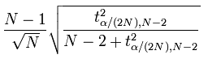 The Grubbs test statistic, Z, is the largest absolute deviation from the sample mean in units of the sample standard deviation. Z= max(|(mean value - single value)|)/standard deviation. “If your calculated value of Z is greater than the critical value in the table, then the P value is less than 0.05. This means that there is less than a 5% chance that you'd encounter an outlier so far from the others (in either direction) by chance alone.” Engineering Statistics Handbook, 1.3.5.17, http://www.itl.nist.gov/div898/handbook/eda/ section3/eda35h.htm. “The Grubbs' test detects one outlier at a time. This outlier is expunged from the dataset and the test is iterated until no outliers are detected.” Wikipedia, http://en.wikipedia.org/wiki/ Grubbs'_test_for_outliers
Definitions for the six services measures are as follows: Attendance This is the total number of persons visiting, i.e., entering the library for whatever purpose. Circulation The total circulation of all library materials of all types, including renewals. This includes all materials in all formats that are charged out for use outside of the library. Interlibrary loan transactions included are only items borrowed for users, only those transactions where the library directly checks out the material to a patron. This does not include items checked out to another library. Virtual Visits The number of virtual visits to networked library resources. A visit occurs when a user connects to a networked library resource for any length of time or purpose (regardless of the number of pages or elements viewed). Examples of a networked library resource include a library OPAC or a library web page. In the case of a user visit to a library web site a user who looks at 16 pages and 54 graphic images registers one visit on the web server. Reference Transactions A reference transaction is an information contact which involves the knowledge, use, recommendations, interpretation, or instruction in the use of one or more information sources by a member of the library staff. It includes information and referral services. Information sources include printed and non-printed materials, machine-readable databases, catalogs and other holding records, and through communication or referral, other libraries and institutions and people inside and outside of the library. The request may come from an adult, a young adult, or a child. Do not count directional transactions or questions of rules or policies. Examples of directional transactions are "Where are the children's books?" and "I'm looking for a book with the call number 811.2G." An example of a question of rules or policies is "Are you open until 9:00 tonight?" Reference transaction can be conducted in person, by phone, by fax or by mail, as well as virtually via email, website or other networked-based medium designed to support virtual reference, including electronic reference. Percentage of Time Public Internet Computers In Use Divide the total number of hours per week Internet computers are actually in use by the total number of hours per week they are available for use. For example, in a library which is open 60 hours a week and dedicated Internet computer(s) are in use 40 hours a week, the percentage of time in use is 67% (40 divided by 60 = .67). Number of Users of Public Internet Computers Report the total number of individuals that have used Internet computers in the library during the period in question. If the computer is used for multiple purposes (Internet access, word-processing, OPAC, etc.) and Internet users cannot be isolated, report all usage. A typical week or other reliable estimate may be used to determine the number. Sign-up forms or Web-log tracking software also may provide a reliable count of users.
? Average as the arithmetic mean determined by dividing the sum of all values in the set by the number of values in the set.
? Average rate of change for the five year span was computed using the following formula: ([4.02%+4.10%+2.82%+3.25%+7.50%]/5) = 4.34%
? The compounded rate of change was computed using the following formula: 100*(1+2.41%)*(1+1.18%)*(1+1.91%)*(1+4.18%) = 110.01-100 = 10.01%
The compounded rate of change was computed using the following formula: 100*(1+2.79%)*(1+0.00%)*(1+1.47%)*(1+1.42%) = 105.78-100 = 5.78%

