|  |  |
| --- | --- |
| wsl-logo | **IMLS_Logo_Black** |

**Library Services and Technology Act**

Quarterly Narrative Report Instructions

The submittal of the quarterly narrative reports allows Washington State Library (WSL) to review the progress made on the project. It summarizes the accomplishments and procurement activities to date, and updates WSL staff on any problems or delays that may have been encountered. It also reports on the expenditures, both amounts obligated and amounts claimed.

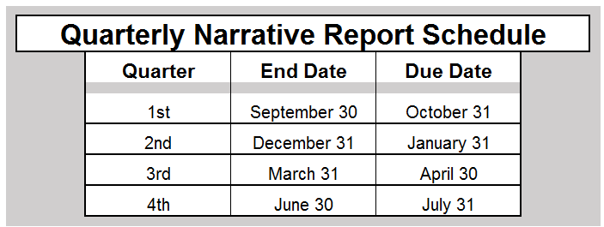

Please mail this report to: LSTA Grants Program

Washington State Library

Post Office Box 42460

Olympia, Washington 98504-2460

And email to: [WSLgrants@sos.wa.gov](mailto:WSLgrants@sos.wa.gov)

|  |  |
| --- | --- |
| wsl-logo | **IMLS_Logo_Black** |

### **Quarterly Narrative Report Cover Sheet**

Date Contract #

Library

Project title

**Reporting Period**

Please check the box corresponding to the quarter ending date.

September 30 December 31  March 31  June 30

Submitted by

Please mail this report to: LSTA Grants Program

Washington State Library

Post Office Box 42460

Olympia, Washington 98504-2460

And email to: [WSLgrants@sos.wa.gov](mailto:WSLgrants@sos.wa.gov)

|  |  |
| --- | --- |
| wsl-logo  **Library Services and Technology Act** | **IMLS_Logo_Black**  **LSTA Grants** |

**Quarterly Narrative Report**

1. Do you feel this grant is helping you provide better service to your customers?

Strongly agree  Agree Neutral  Disagree  Strongly disagree

If you disagree or strongly disagree, what would need to change in order for you to consider that the grant is helping you to provide better service?

1. Summarize project progress.Click here to enter text.
2. State any problems encountered that may create significant delays or affect the outcome of the project.Click here to enter text.
3. List specific objectives and activities accomplished to date.Click here to enter text.
4. Summarize any implemented evaluation activities.Click here to enter text.
5. Summarize equipment or materials purchased to date.Click here to enter text.
6. Summarize procurement activities (such as personal service contracts, vendor selection, vendor’s performance) not yet completed and include estimated completion date.Click here to enter text.
7. Complete the following table:

|  |  |  |
| --- | --- | --- |
| **Amount Awarded** | **Amounts Claimed** | **Amounts Expended, Not Yet Claimed** |
|  |  |  |

Amounts entered should correspond to the end of the quarter being reported.