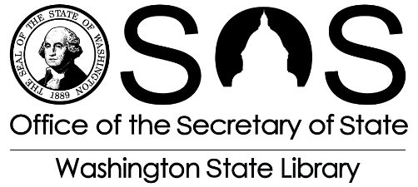
Microsoft Imagine Academy 2016 – 2017 Microsoft Certification & Coding Grant

Final Report
Final Narrative Report Instructions

Please complete and send the Final Report for your Microsoft Imagine Academy Project. This helps
Washington State Library (WSL) review the progress of the project. It recaps your accomplishments and reports on your expenditures.

Please mail your completed report to: Microsoft Imagine Academy Project
Washington State Library
Post Office Box 42460
Olympia, Washington 98504-2460

And email a copy to: WSLgrants@sos.wa.gov

Date Contract #

Library Name______________

Project Title ___________________

Project Manager Name____________ __________________________________________________________

Project Manager Email_______________________________________________________________________

Project Manager Phone

Microsoft Imagine Academy 2016 – 2017 Microsoft Certification & Coding Grant

Final Report

- Review your grant project activities and list specific objectives and activities accomplished. Please include:
  - Number of classes/events
  - Methods used to recruit participants
  - Number of participants

- How did you evaluate your activities? Please include copies of the tools used and summarize your results.

- What’s changed in your community because of this grant?

- Explain what equipment and promotional materials you attained with grant funds. Were any funds left unspent, and if so, why?

- Please describe your plans for continuing grant-inspired MOS and coding programming into the future. Please include any resources and support that will help you achieve your objectives.

