Working with People with Albinism in Tanzania
Friendly Water for the World

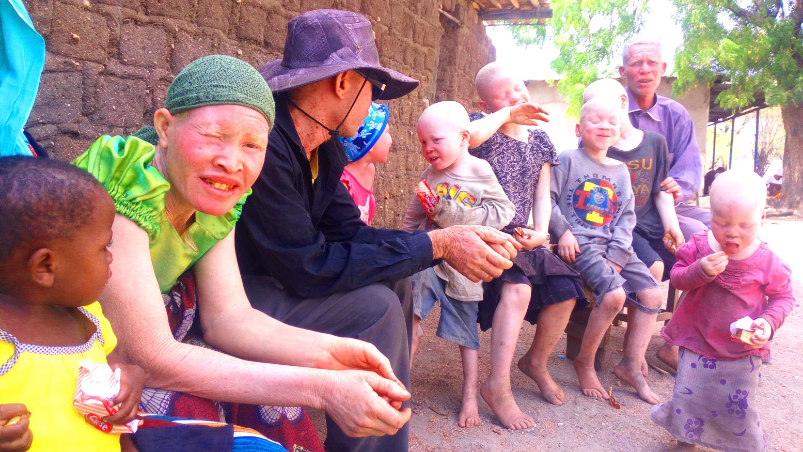
People with albinism are found throughout Africa, especially in the eastern and central regions. A lack of skin pigmentation (melanin) - a genetic condition - results in people appearing white (actually pinkish), with skin burning easily in the equatorial sun, and often with severely impaired eyesight. The physical condition would itself be difficult enough to manage – long clothes, hats, body lotions, strong eyeglasses – but worse is the social situation in which people with albinism find themselves.
People with albinism in Tanzania live in constant fear. They are hunted, killed, and dismembered, especially by those in fishing and mining communities. Witchdoctors teach these communities to believe that possession of bones and body parts from people with albinism can lead to wealth. More than 100 people with albinism are killed and gruesomely mutilated in Tanzania each year. It should be noted that many are killed while walking to gather water for their households. There is also a myth that sex (i.e. rape) with a woman, boy, or girl with albinism is a cure for HIV – hence, many of those raped are infected with the disease.
Since they have no way of protecting them in their own communities, the Tanzania government has chosen to collect people with albinism in camps, where they receive very minimal aid from other community-based or non-governmental organizations.

Shinyanga is one of five regions in in the Lake Zone of northern Tanzania. There are some 2,700 people living with albinism in the area; the family count is larger, because many families with children with albinism may not be people with albinism themselves. Conditions in the camp are brutal. Umemployment is virtually 100%. People are constantly sick, there is a massive water scarcity, and it was not unheard of for people to walk 15 kilometers roundtrip to find water. There have been attacks on people of albinism when going for water, or simply using the bushes to relieve themselves. There are no toilets. Typhoid and bacterial dysentery are common, and almost universal. Life expectancy is short.

The Project

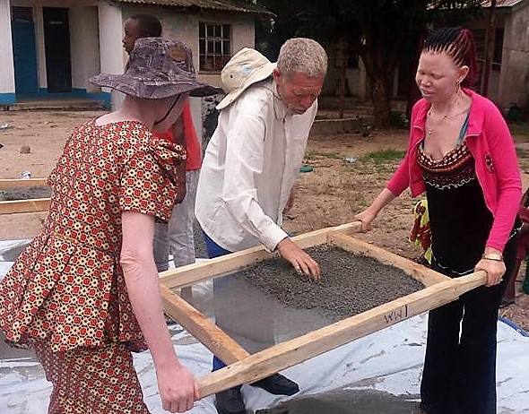
Friendly Water for the World’s project will be implemented in four stages. The first, now completed, provided training in the manufacture, distribution, installation, and maintenance of BioSand Filters. This made it possible for two groups of people to set up small enterprises to sell the Filters, while providing clean water for their own families and community. More than 500 have already been sold. This is the first effort to help reintegrate people with albinism into the larger community, as they have become the only available source of clean water technologies. Profits are now being used to spin off other small enterprises, such as chicken and goat raising or sewing projects. And the improvement in health has been extraordinary!
The second step will be train people with albinism to build rainwater catchment systems/ferro-cement tanks. First, we will train and equip two teams to fabricate interlocking bricks, which will be used for the foundations of the catchments (and for the MicroFlush toilets – see below.) The bricks can also be sold into the community to assist with housing needs. Then we will train two teams of people with albinism to build the catchment systems. The newly available water will substantially reduce the ‘long walk to water’ for many people with albinism and hence eliminate their being hunted in the process, while at the same providing employment and a path to self-sufficiency. Water can also be sold, increasing economic opportunity.
The third stage will be teaching people with albinism to build MicroFlush toilets. MicroFlush toilets are simple, very inexpensive, composting toilets, making use of worms, and requiring only one-quarter cup of water per use. They do not have to mucked out for two-and-a-half years, and are very simple to fabricate. Two more businesses will be created.
Finally, teams in Shinyanga and Geita will be trained to manufacture and market Friendly Soap – a simple liquid soap that does not require palm oil (and hence the destruction of palm trees in the process.)
The overall result will be an integrated program for people with albinism, the very first of its kind, with significant enhancements in both water availability and water quality, and improvements in community sanitation and hygiene. It will remove some of the risks faced by people with albinism from people who are hunting them. It will also provide for job creation and self-sufficiency, and the opportunity for people with albinism to work with members of other communities, a significant step towards the removal of stereotypes. Health of children will be improved, enabling them to attend school more regularly, as many of them will no longer being taken out of school to walk for water.
Word of Friendly Water’s program has spread. Local government officials and leaders of people with albinism communities all over the country are contacting our local affiliate. In addition, the Office of the President of Tanzania has requested that all local governments cooperate and collaborate with our efforts to ensure clean water for people with albinism throughout the country.

Become part of the campaign. JOIN US! We are Friendly Water for the World!
www.friendlywater.net

