Date

Name
Address

Dear :

On behalf of our office and everyone involved in the Washington State Combined Fund Drive, I would like to express my heartfelt gratitude for your contribution to this year’s [Event Name Here ].

Your [Item Name] will be an excellent addition to our [i.e. Silent Auction, Chili Cook off]. Your donation to the CFD is a tax deductible donation (tax number 91-6001106).

Again, thank you for your contribution to the Combined Fund Drive. The CFD is just one of the ways to show compassion, and your tireless efforts will no doubt help to make our community better.

Thank you so much for everything you’ve done. You’re time and effort has truly made an impact on the lives of others.

Sincerely,
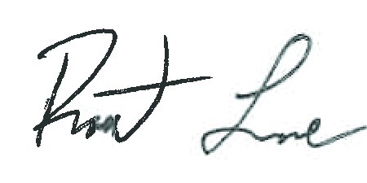
Robert Lane
Program Manager
Combined Fund Drive

