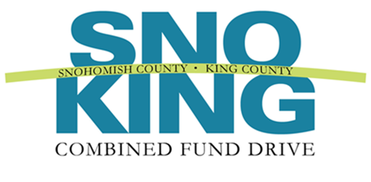

2017 Spirit of Service Award

Nomination Form

The Spirit of Service Award is presented annually to veteran CFD coordinators who have gone the extra mile during the Combined Fund Drive campaign. Each agency may nominate their best and brightest coordinators; those coordinators who have helped make the CFD campaign a success. You may use this form to nominate co-coordinators.

Nominee:
Email and telephone number:
Agency:
Supervisor’s name, email, and telephone number:*
Your name and title:
Phone number and email:

* CFD wishes to notify the nominee’s supervisor

Please complete the following form. The information you provide will be used to determine award winners and may be highlighted at the annual recognition event. Please be clear and as detailed as possible. The form will expand as you type.

1. | In 500 words or less, describe the nominee’s motivation and effort. Please consider the following in your narrative: What made this CFD coordinator’s involvement in the campaign so valuable? How did the coordinator inspire others? (This may include how he/she motivated employees to donate and/or participate in events, secured volunteers to help with the campaign, engaged all staff, etc.) What do you feel were the most outstanding characteristics of this individual’s campaign efforts? How did the volunteer educate staff about the benefits of giving through the Combined Fund Drive? You may expand your narrative beyond the questions to describe specific accomplishments or skills.  Response:
 | Please email this form to Jolyn Mason, UWCFD Development Coordinator, at jolynm@uw.edu, by December 30, 2017.

