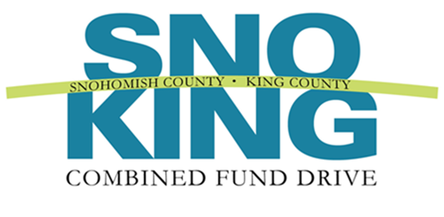
2017 Innovative Event Award
Nomination Form

The Innovative Event Award is presented annually to event coordinators who demonstrate exemplary outreach and innovation while promoting and educating employees about the benefits of giving through the CFD.

Name of the Event:

Agency:

Name of coordinator:

Email and telephone numbers:

Supervisor’s name, email, and telephone number:*

Your name and title:

* CFD wishes to notify the nominee’s supervisor

Please complete the following form. The information you provide will be used to determine award winners and may be highlighted at the annual recognition event. Please be clear and as detailed as possible. The form will expand as you type.

1. | In 500 words or less, describe event participation. Please consider the following questions in your narrative: Were charities invited to participate? How many employees were invited? How many attended? How was the event promoted? You may expand your narrative beyond the questions to describe specific accomplishments or skills.  Response:
2. | In 500 words or less, describe event innovation. What made the event so remarkable? What was the purpose of the event (i.e., education, charity awareness, increasing payroll deduction, raising money, etc.?) Was this an annual or first time event?  Response:
3. | In 500 words or less, describe the event results. How did your agency benefit from hosting this event? Did the amount of money raised exceed the effort expended? Did your agency utilize any new resources (i.e., funds, people power, in kind donations, etc.?) Did the event lead to increased contributions and/or participation? Did the event coordinator ensure that giving forms were available? If raising money was an objective, how much money was raised? You may expand your narrative beyond the questions to describe specific accomplishments or skills.  Response:
Please return this form by email to Jolyn Mason, UWCFD Development Coordinator, at jolynm@uw.edu, by December 30, 2017..

