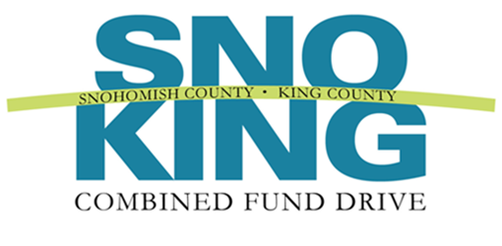
2017 Outstanding Campaign Team Award
Nomination Form

This award is presented annually to a group of CFD volunteers that demonstrates exemplary team work while promoting and educating employees about the benefits of giving through the CFD.

Name of Team:
Agency:
Team Members’ Names:
Email and telephone numbers:
Supervisor’s name, email, and telephone number:*
Your name, title and email:

* CFD wishes to notify the nominee’s supervisor

Please complete the following form. The information you provide will be used to determine award winners and may be highlighted at the annual recognition event. Please be clear and as detailed as possible. The form will expand as you type.

1. | In 500 words or less, describe the team’s commitment to teamwork. Please consider the following in your narrative: How did the team demonstrate teamwork and show superior effort in completing campaign related tasks? What skills did these individuals contribute to the team in creating a positive work environment? You may expand your narrative beyond the questions to describe specific accomplishments or skills.  Response:
2. | In 500 words or less, describe the team’s motivation and performance. Please consider the following in your narrative: How did the volunteers engage management and staff in the campaign? What were the outstanding attributes of the team’s campaign efforts and how did they result in a better campaign for your workplace? Attributes might include vision, collaboration, accessibility, strategic thinking, communication, financial responsibility, ethical behavior, and respect for employee decisions. Were campaign goals set? Did the team achieve their goals? You may expand your narrative beyond the questions to describe specific accomplishments or skills.  Response:
Please return this form by email to Jolyn Mason, UWCFD Development Coordinator, at jolynm@uw.edu, by December 30, 2017.

