Charter
Washington’s Information Governance Initiative
July, 2014

Business Problem
The state of Washington and its agencies have been accumulating electronic documents and information for more than thirty years without a consistent filing system or defensible approach to retention, retrieval, and disposition. In many cases, employees are left to create their own filing systems to store documents. No system allowed for systemic destruction of data past retention. As a result:
- Employees waste a great deal of time searching for and/or recreating mission-critical documents because they are not systematically filed.
- They make copies of frequently used or hard to find documents and store them where they can find them, but no one else can.
- Documents are isolated in silos and stored in multiple locations unknown to others.
- There is no practical way to identify and destroy documents that have passed retention and are eligible for destruction.
- The amount of redundant, obsolete, and transitory data in our systems grows exponentially.
- These conditions complicate agency efforts to respond to public records requests, and increase related costs and exposure to risk.

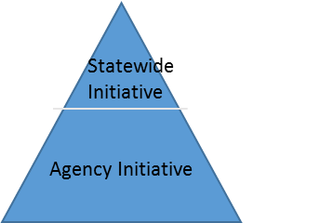
Purpose for Initiative
The purpose of this statewide initiative is to remove the major barriers to agency information governance initiatives. This will be accomplished by providing breakthrough information governance principles and selecting an array of Enterprise Content Management (ECM) systems for agencies to use.

As agencies implement breakthrough principles and guidance with an ECM System in their own initiatives, employees will be able to effectively organize, manage, and use electronic documents and unstructured data as a critical agency asset. Agencies will be able to resolve electronic records disorganization and proliferation issues, and the related problems that flow from those issues.

Expected Outcomes of This Initiative
- Help agencies overcome the cultural and operational barriers to implementing their own Information Governance initiatives, and provide a roadmap for implementation
- Resolve misconceptions and disagreements over how records management requirements apply to managing electronic documents and other unstructured data.
- Bring together records management, public disclosure, Information Technology security, and other disciplines necessary to develop records management solutions
- Enable agencies to choose from a small list of ECM systems that meet state requirements. Save agencies the time and effort to evaluate systems and satisfy competition.
- Make expert level contractors available to agencies to help them plan and execute Information Governance initiatives in the most expedient fashion. Save agencies the time and effort to evaluate contractors and satisfy competition.
- Provide state level executive support to agencies choosing to implement information governance initiatives, and encourage adoption of information governance principles across state government.
- Pave the way for “Lean Transformation” through better use of resources, decreased waste, improved business processes, and increased transparency

Scope
Included in scope:
- Develop and vet guidance for agencies on how to implement information governance
- Evaluate and select ECM or records management systems
- Develop contracts with information governance consultants
- Promote statewide adoption of Information Governance and ECM initiatives
- Conduct short-term pilots of ECM systems implementation

Excluded from scope:
- Information governance activities in individual agencies
- Implementing production ECM and records management systems in agencies

Approach
- Establish multi-agency, multi-disciplinary teams, laid out below, to complete key deliverables
- Teams will conduct their work in parallel
- Teams will collaborate and improve their respective materials as they gather input from agencies

Listed below is a summary of the teams, with their respective purposes and dates that comprise this initiative. Please refer to the individual project team descriptions for more detail on scope, deliverables, and dates for each team.

Project Team | Purpose | Date
Information Governance  Principles and Guidance Team | Refine breakthrough principles and guidance, that when implemented with ECM Systems, enable agencies to effectively store, find, manage, and disposition electronic records and unstructured data.  Vet the principles and guidance with:  - Executive sponsors  - Agency business, records, legal, and technology subject matter experts  Gain statewide support to help reduce electronic records management barriers and resolve disagreements and misconceptions. | October, 2014
ECM System Selection Team | Select and satisfy competition for a limited number of ECM or records management systems.  - Provide ECM options that meet the business needs of a variety of agencies  - Examine hosting alternatives, implementation, operations, and cost of the options selected | December, 2014  (To be validated by this team)
ECM System Proof of Concept Team | Selected agency business units will conduct limited scope, proof of concept projects to:  - Validate the business value of ECM/IG adoption  - Test and refine Information Governance principles and guidance for agencies | February, 2015
Consultant Selection Team | Select and satisfy competition for a suite of information governance contractors who can help agencies:  - Plan and implement Information Governance and ECM initiatives based on agency needs  - Realize value quickly  - Manage organizational change and momentum in the agency | October,  2014
Communications Team | Develop and execute the Communications plan.  - Promote statewide adoption of Information Governance and ECM systems.  - Deliver information and training to support agency participation. | July,  On-going

Steering Committee Members
Michael Cockrill, State CIO
Nick Brown, General Counsel to the Governor
Nancy Krier, Public Record Ombudsman, ATG
Joe Shorin, E-Discovery and E-Disclosure, ATG
Chuck Pfeil, Deputy State Auditor, SAO
Ro Marcus, Assistant Director for Legislative Affairs, OFM
Kim Wyman, Secretary of State
Steve Excell, State Archivist, SOS
Lucy Isaki, State Risk Manager, DES
Joe Stohr, Deputy Director, DFW
Jessica Todorovich, Deputy Director, DOH
Lynne McGuire, Deputy Director, DES
Christy Ridout, Deputy Director, CTS

Steering Committee Role
- Provide executive level support for statewide and agency level information governance initiatives
- Help align the outcomes of this initiative with state and agency business needs
- Offer guidance to address issues

The Steering Committee is expected to meet quarterly.

Project Organization

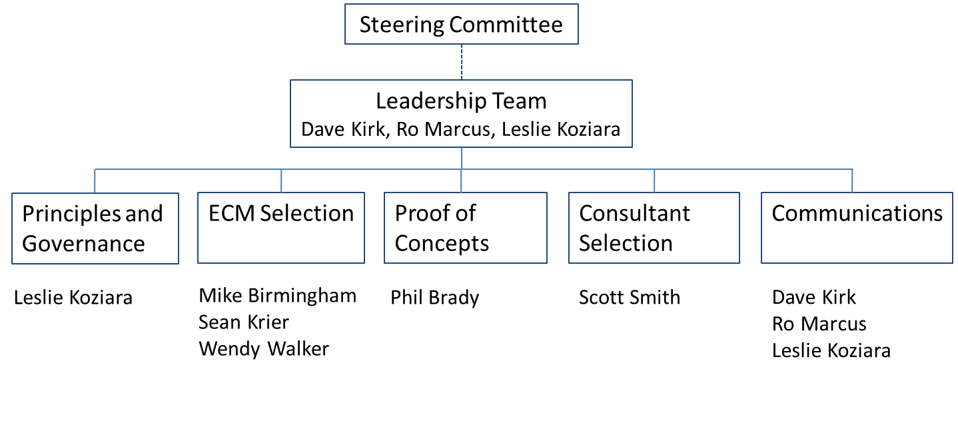

Related Activities and Initiatives
- Online file storage and synchronization contracts (BOX, others to be announced)
- Open data initiatives
- Paper records Act
- State mobility strategy
- Results Washington, lean initiatives
- Public records requests
- E-Signatures
- State shared services
- Requirements for cross agency collaboration and information sharing

