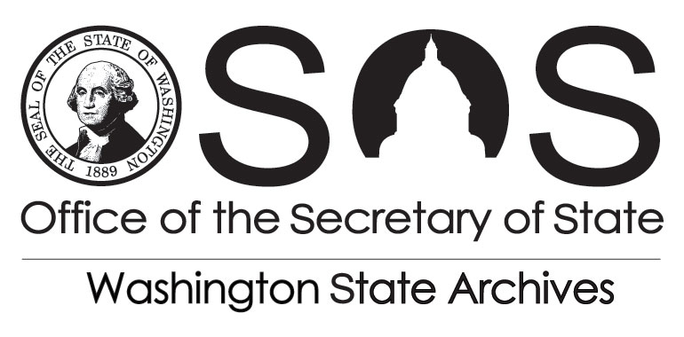 | Division of Archives & Records Management  PO Box 40238  Olympia, WA 98504-0240

REQUEST FOR MICROFILM DUPLICATE

Send completed form to securitymicrofilm@sos.wa.gov
STATE/LOCAL GOVERNMENT NAME
DIVISION |  |  |  |  |  | DATE
CONTACT NAME |  |  | PHONE NUMBER
BILLING CONTACT NAME AND E-MAIL ADDRESS |  |  | PHONE NUMBER
BILLING ADDRESS AND/OR MAIL STOP |  |  | SHIPPING ADDRESS
QUANTITY | SERVICES | UNIT  PRICE |  | UNIT | TOTAL
 | M-Type Cartridge | $3.50 |  | Per Cartridge
 | ANSI Clip | $1.25 |  | Per Clip
 | Magazine Clip | $1.25 |  | Per Clip
 | 16 mm Digitizing Whole Reel | .05 |  | Per Image
 | 35 mm Digitizing Whole Reel | .13 |  | Per Image
 | Image Enhancement | $65.00 |  | Per Hour
 | 16 mm Digital Conversion Up To 25 Images No Charge | $50.00 |  | Per Hour over 25 images
 | 35 mm Digital Conversion Up To 25 Images No Charge | $50.00 |  | Per Hour over 25 images
 | 16 mm x Diazo on Spool | $17.00 |  | Per Roll
 | 35 mm x Diazo on Spool | $21.00 |  | Per Roll
 | 16 mm x Silver on Spool | $39.00 |  | Per Roll
 | 35 mm x Silver on Spool - Negative | $39.00 |  | Per Roll
 | 35 mm x Silver on Spool - Positive | $39.00 |  | Per Roll
 | Microfiche Duplication | $1.55 |  | Per Sheet
 | Compact Disk | $15.00 |  | Each
 | Shipping and Handling (UPS Rates) | Cost of Shipping +30%
 | EXPEDITE SHIPPING | $21.00 |  | Per Roll
RECORD SERIES, DATES, REEL #’s SEE ATTACHED INVENTORY

STATE/LOCAL GOVERNMENT OFFICIAL SIGNATURE |  |  | STATE ARCHIVIST SIGNATURE
PRINT/TYPE NAME |  |  | PRINT/TYPE NAME
DATE |  |  | DATE
For Security Microfilm Use Only
Vault Location: |  |  | Retrieved By: Date:
Received By: Date: |  |  | Returned to: Date:

