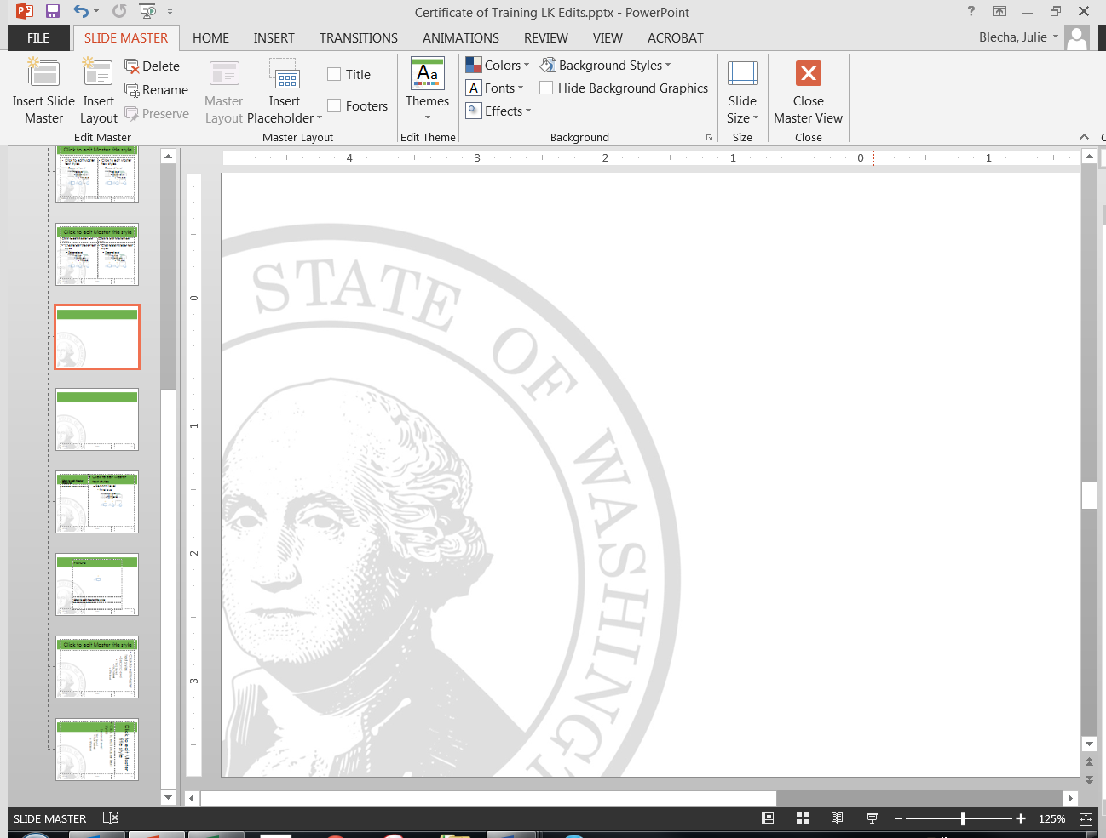

[NAME]

[Entity/Agency]

*Completed the following training:*

□ **Basics of Managing Records** [Hours]

Date Training Received: [Date]

□ **Improving Your Agency’s Records Management Program Workshop [**Hours**]**

Date Training Received: [Date]

□ **Organizing the File Room Workshop [**Hours**]**

Date Training Received: [Date]

□ **Going Paperless Workshop [**Hours**]**

Date Training Received: [Date]

□ **OTHER______________________________ [**Hours**]**

Date Training Received: [Date]

**Format:**

□ In-person training by: [Name of trainer(s)]

□ Online Training (including webinars): [List website address, online materials viewed, name(s) of webinar presenter, other relevant information]

□ Other format: [Describe]

***I hereby certify that I received this training:__________________________________________________________***

***Signature & Position or Title***

Certificate of Training