Offboarding Employee Process: Managing Email Records
Outlook records may be shared with other employees when the account is active, but once an employee’s account is de-activated it is no longer accessible to supervisors. Emails that have been labelled with retention labels will be available for eDiscovery after an employee has left. Emails that did not receive retention labels prior to being de-activated may be retained as long as 60 years after the employee has left.

Tasks to complete within 30 days following the employee’s last day:
☐ Confirm access to employee’s email account by looking for the exited employee’s name in the folder panel on the left of the screen. You may need to restart your machine if it doesn’t show up right away.
☐ Review this guidance document and corresponding video instructions to learn how to apply retention label policies to individual emails and folders.
☐ Apply retention labels to emails in “System folders”. Please note: you cannot apply retention label policies to system folders and must apply the retention directly on the email items within the folder.
Steps to complete:  - Drafts, Deleted Items and Junk Email folders:  Select all items by clicking CTRL + A. Right click and click “delete” or choose a short retention label like 3 or 6 months.  - Inbox, Sent Items, Archive, Conversation History, Outbox, and RSS Subscriptions:  Select all items and move to retention folder or apply appropriate retention label*.  *Please use a default retention of “6-Years-Delete-Labelled Date” | 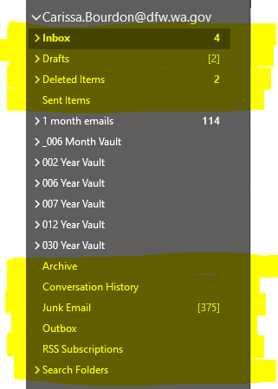

☐ Review every other folder in the exited employee’s folder structure to verify if a retention label has been applied.
Steps to complete:

- Right click on a retention folder and click on “Properties”

- Under the “Policy” tab look to see if the Folder Policy drop down menu has a retention policy selected.
(example to the right has selected a 6 month delete folder policy for the _006 Month Vault folder)

- Choose one if it is not already selected*

*if the exited employee’s folders are not labelled with the recommended retention setting use a default: “6-Years-Delete-Labelled Date”

☐ Email the Service Desk directly to request retention policy assistance or if you have questions about records management and retention.
Additional resources:
- Use this “Retention Schedule Look-up Tool” to determine retention requirements for records.
- Here are additional retention schedule resources.
- O365 Champions Exchange Online (Outlook email) FAQs
- Here is a list of example transitory emails that can be deleted or labelled with a short retention label.

