

This monthly reminder is part of an essential office-wide cleanup effort of all electronic records.

We have a quick, easy activity in MS Outlook that you can do to help.   
READY…  
Right-click on your “Deleted Items” folder then scroll down and click on “Empty Folder”.   
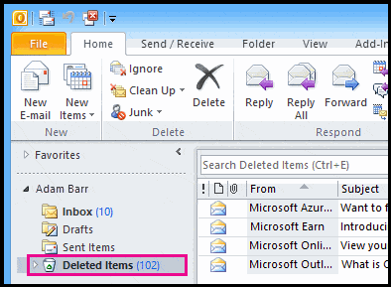Thank you for taking the time participate as we free space on our servers and networks.

Please contact us if you have any questions.

XXX XXXX