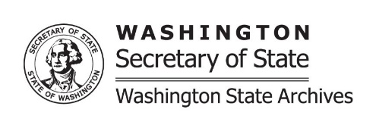 | ARCHIVES RECORDS TRANSMITTAL &  BOX CONTENT LIST
 | Archives  Use Only | Received By | Date | Accession Number

Name of Agency |  |  |  | Office / Sub-Division |  | Records Officer
Records Officer Telephone Number |  |  |  |  | Records Officer E-mail
Location | Box/Vol#/  Reel#/Barcode |  | Record Series / File Title |  |  |  | Dates |  |  | DAN
TRANSFER OF CUSTODY AGREEMENT
Agency hereby transfers the authentic records listed above to the custody and jurisdiction of the Washington State Archives. Except as noted above, the records have been in Agency’s custody for the duration of their existence and are not subject to statutory exemption or other restriction. Archives and Agency concur that any records subject to statutory exemption or other restriction have sufficient historical, legal and/or fiscal value to warrant making them publicly accessible after passage of the requisite period of time, per 40.14 RCW. The records will become and remain the property of the State of Washington and will be stored, referenced, managed and disposed of in accordance with applicable laws and regulations, the policies and procedures of the Division of Archives and Records Management, and the instructions of the State Archivist.

______________________________________ ______________________________________
Signature of Agency Official Date Signature of Archivist Date

Revised 7/31/2019

