Washington Talking Book & Braille Library

Administered by the Washington State Library

and Office of the Secretary of State

Reading Matters

Fall/Holiday 2011

David Junius, Editor

A Message from Danielle Miller, Program Manager

Fall in Washington used to represent the beginning of the holiday season and an increase in gray, rainy days. Now, the most looming aspect of fall is budget and legislation. But, before talking about that, let me wish you all a happy and healthy holiday season and belated recognition and gratitude to our veterans. I would also like to thank the Washington Council of the Blind and the National Federation of the Blind of Washington for their outstanding annual conventions. It is always a joy and an honor to participate.
In the last couple of months, some exciting things have been going on at your library. We started another session of our braille transcription course and have 18 students learning the art and science of turning print into braille. Hopefully, when the students finish the nine-month course, they will volunteer with us to produce braille for our collection, or use their transcription skills in a way to benefit the community of braille readers and help keep braille available for children and adults eager to learn.
Another format for accessing information, the digital talking books, is fast replacing the cassettes as our workhorse. As of September, more digital books circulate physically by mail than cassette books. If you also count the digital downloads from BARD and our WTBBL download website, digital circulation is well over half of all our circulation.
Finally, the budget...
The continued economic problems and lack of revenue in Washington are requiring yet more cuts from state agencies. WTBBL, and our parents, the Washington State Library and the Office of the Secretary of State, have been enduring budget cuts for years. Through the cuts and reductions in staff, we have tried to continue to provide all the services people are accustomed to; however, this latest round of cuts simply makes that impossible.
We were asked to turn in cuts of 10 percent, and Governor Gregoire called a special session of the Legislature to meet after Thanksgiving. The special session could cut deeper, as could the regular session beginning in January. In order to meet the currently requested cut of 10 percent, we will be greatly reducing our Evergreen Radio Reading Service. This decision was painful and none of us wants to lose levels of service or funding that goes to provide material and programs to people who cannot comfortably read standard print.
It is difficult to be the bearer of bad news so often these past few years, but know that I, and all of us at WTBBL and the Washington State Library, are doing the best we can to keep our service thriving. Creativity and persistence are highly valued in times like these. I hope we will continue to be an important organization for you and that we can continue to grow stronger and more nimble.
As always, I greatly appreciate your comments and questions.

Danielle
danielle.miller@sos.wa.gov or (206) 615-1588


A Word from Rand Simmons, Acting State Librarian
One of the certainties of life is change. Some things change slowly, but everything changes either through atrophy or through growth. We all know that change can be difficult, more so for some than for others. Progress is linked to change and without change there can be no progress.
During this decade the Washington State Library (WSL) has lost 39% of its state funding and 52% of its staff. With the Legislature called into a 30-day special session beginning on November 28, the outlook is bleak and we are expecting a minimal cut of 10 percent in our state funding. Economic recovery has been slow in Washington State and we may well see further cuts from the Legislature this spring.
The bright side of loss is the opportunity to grow. Every program in the Washington State Library has been cut proportionately to the amount of state funding it receives, including WTBBL. With significant cuts in operations and staffing we are left with few choices about where to reduce spending.
This year I decided that we would eliminate the Evergreen Radio Reading Services (ERRS). I arrived at this decision after discussions with Danielle Miller, WTBBL’s Program Manager. The decision was not made lightly. Of all of WTBBL’s wonderful services for its customers, the ERRS was the most costly and was accessed by the fewest patrons.
The zeal with which staff and volunteers have contested this decision speaks highly of the services provided by ERRS broadcasters John Pai and Gregg Porter, and our numerous volunteers. However, we have not seen a swell of concern by our listening audience after many calls for comment. I believe these listeners are finding other means of meeting their recreational and informational needs. So, I stand firm on my decision.
We believe we can provide more fitting and up-to-date services to our ERRS listeners. We will re-envision the services the ERRS has provided. The equipment will be used for other purposes such as audio recordings. We will point our customers to other resources that will meet their informational and recreational needs. We can deliver reading of the grocery ads and airing of talk shows and author interviews by moving them into an online environment via our existing Internet streaming and podcast and download site. We will not abandon our patrons.
Wherever this message finds you I hope you will have a joy-filled holiday season. Please know that the WSL and WTBBL care very much about bringing the best services possible to you, our cherished supporters and customers.

RADIO WAVES by John Pai

In life, unfortunately, all good things do come to an end. Due to the continuing budget issues affecting our state as of December 31, 2011, the Evergreen Radio Reading Service (ERRS) will cease broadcasting as we have come to know it over the past 38 years.
ERRS was the second radio reading service launched nationally right after the formation of the Minnesota Radio Reading Service in 1973. It has served the community well, providing more than 168 hours of local programming a week and giving voice to local magazines and newspapers of the Pacific Northwest.
Each program was carefully constructed and voiced by one of our 85 volunteers working as a researcher and editor to provide the most urgent and timely news and information. With its demise, an alternate service will be launched and maintained largely via the Internet and possibly through the FM-SCA network that we have been using. It will be comprised primarily of programs available from other radio reading services and a handful of locally based readings. Ninety percent of the local programming will be replaced, save for a scaled-back reading of the Seattle Times and the programs “TV Times,” “Grocery Cart,” “Eastern Bargains” and “Shopping News.” Additional programming could be reinstated or changed as budget issues evolve and patron usage of the radio service is measured.
Unfortunately, we will be losing the two broadcasters on staff, and the majority of the 85 volunteers who have worked year in and year out to provide the most up to date and cogent information and materials otherwise unavailable to our listening patrons. Several have been with us for over 20 years, and the majority has contributed at least five years of service. Some have pushed past 36 years with the service.
Enough cannot be said about the dedication that the ERRS volunteers have brought to this service. Even during the darkest times, they were continuing on and trying to help find a solution. We have all been blessed by their efforts throughout the years and in these final days.
Both Gregg Porter and I have been honored to have worked with our volunteers and for the patrons who have listened all these years.

THANK YOU.

Author Profile: Laura Hillenbrand by Amy Ravenholt
When Laura Hillenbrand was 19, she found herself incapacitated after a bout of food poisoning. Her doctor couldn’t find a cause, and told her to see a psychiatrist. The psychiatrist told her she was sane, so the problem must be physical. Too weak and dizzy to move, her world narrowed down to her bed and window. When no doctor could diagnose her condition, people told her she was lazy and selfish.
In sleep, she dreamed of being an athlete. Awake, she struggled to research and write magazine articles. She remembers, “I was sifting through some documents on the great racehorse Seabiscuit when I discovered Red Pollard, the horse’s jockey. I saw him first in a photograph, curled over Seabiscuit’s neck. Looking out at me from the summer of 1938, he had wistful eyes and a face as rough as walnut bark. I began looking into his life and found a story to go with the face.”
She became obsessed with researching Seabiscuit, and piecing together the stories of the three men who made a long shot into a winner. When she was too dizzy to read, she lay down and wrote with her eyes closed. She did interviews on the phone from bed, and could write only a few paragraphs a day. It took two years for her to complete the book, but only two weeks for it to hit number one on the bestseller list.
Laura’s condition, finally diagnosed as chronic fatigue syndrome, actually worsened for a while after the success of her first book in 2001. Through the exhaustion and vertigo, she continued to research. She says it was Seabiscuit that led her to the athlete who was her next subject--Louie Zamperini.
He was a juvenile delinquent turned 1930s track star who persevered through incredible hardships adrift at sea and in a Japanese prisoner of war camp. Over seven years, Laura used phone calls, email and letters to draw the story out of Louie and his fellow prisoners. The result was her second book, Unbroken, another New York Times bestseller in 2010.
The woman who can barely walk around the block finds escape in athletes of another era. And through her words, we can be there, too.

Both books are available now from WTBBL:

Seabiscuit: An American Legend
In 1938, a year of monumental turmoil, the number one newsmaker wasn’t Franklin Roosevelt or Adolf Hitler. It wasn’t even a person. It was an undersized, crooked-legged racehorse owned by a bicycle repairman-turned-automobile magnate, trained by a virtually mute mustang breaker, and ridden by a half-blind failed prizefighter. The racehorse was Seabiscuit. This is his story. 2001.
Available in braille book BR14930; digital book DB51968; cassette book RC 51968; and large print book LP17981.

Unbroken: A World War II Story of Survival, Resilience, and Redemption
Details the life of Louie Zamperini (b. 1917), an Olympic runner and World War II bombardier, who survived a plane crash and 47 days adrift at sea only to become a POW in Japan. Relates Louie’s later religious awakening under Billy Graham’s ministry. Violence. Bestseller. 2010.
Available in digital book DB072129, and large print book LP025279.

(This article uses quotes and material from Hillenbrand’s 2003 New Yorker article on her experience with Chronic Fatigue Syndrome, “A Sudden Illness—How My Life Changed,” available at http://www.cfids-cab.org/MESA/Hillenbrand.html.)

Just for Fun by Theresa Connolly

I was home poking around for something fun and easy to read the other night and I could not settle on anything. My books seemed too scary, complicated or emotionally fraught to read at bedtime. I knew not reading anything would keep me awake, so I rummaged until I found the solution. Children’s books. Ten minutes and two books later, I had funny and lovely things to think about as I drifted off to sleep.
At work, with that satisfaction in mind, I put together a compilation of children’s stories recorded by volunteer narrators here at WTBBL. There are 10 stories, with the shortest at two minutes and the longest at eight minutes. The stories are for little children on up.
The compilation includes: I’m Not Going to Chase the Cat Today; Moo in the Morning; The Turnip; Round as a Mooncake; Chicka Chicka Boom Boom; Too Much Noise; I Love You, Little One; Clara Ann Cookie; Owl Babies and Big Plans.
If you would like this for your child, or for yourself, contact the library and ask for The Children’s Compilation DBW8328. You can also download it from our website at http://www.wtbbl.org/login.aspx.
I know the narrators enjoyed recording the books; I liked listening, so my guess is you will have fun listening, too.

NEW Books Available at WTBBL by Herrick Heitman
Here are some of the audio and braille books we have recently produced. These descriptions and the downloadable audio books are added to our website as each book is completed. Digital cartridge copies are available for checkout.

Audio: Adult Fiction
Curtain Creek Farm: Stories by Nance Van Winkle.
Thirty years later, the quirky, idealistic residents of Curtain Creek Farm--a Sixties commune in Washington State--still make sandals, weave blankets, and grow organic vegetables. But now they have a website; their children are having children; and into their underground homes, tree houses, and tin-roofed cabins, aging parents are coming to live with them. 2000. DBW 8219. Also available for download from WTBBL.

Audio: Adult Nonfiction
Beyond Forgetting: Poetry and Prose about Alzheimer’s Disease, edited by Holly Hughes.
This compilation has poetry and prose written by 100 contemporary writers whose lives have been touched by the disease. The writers are people in the medical professions, family members, and social workers. This book of personal stories is a valuable companion for anyone embarking on the difficult journey of taking care of someone with Alzheimer’s. Their words help us see “...the unlikely light shining deep within it.” 2009. DBW 8231. Also available for download from WTBBL.

Braille: Adult Fiction
Fire and Ice [#14, Joanna Brady and #19, J.P. Beaumont] by J.A. Jance.
Seattle detective J.P. Beaumont looks into the murders of six young women. Meanwhile, Cochise County Sheriff Joanna Brady in Arizona probes the death of a man crushed by an all-terrain vehicle. The two investigators --first seen together in Partner in Crime (BRW01017 )--find connections between their cases. Some strong language. 5 volumes. 2009. BRW 1305.

Braille: Adult Nonfiction
White Grizzly Bear’s Legacy: Learning to Be Indian by Lawney Reyes.
Lawney Reyes grew up in the Eastern Washington Indian village of Inchelium that flooded after the construction of Grand Coulee Dam. He describes the changes forced on his tribe and how he was sent to an out-of-state Indian boarding school under court order. 2002. 4 volumes. Braille Book BRW 1308.

Volunteer Spotlight: Ken Newman
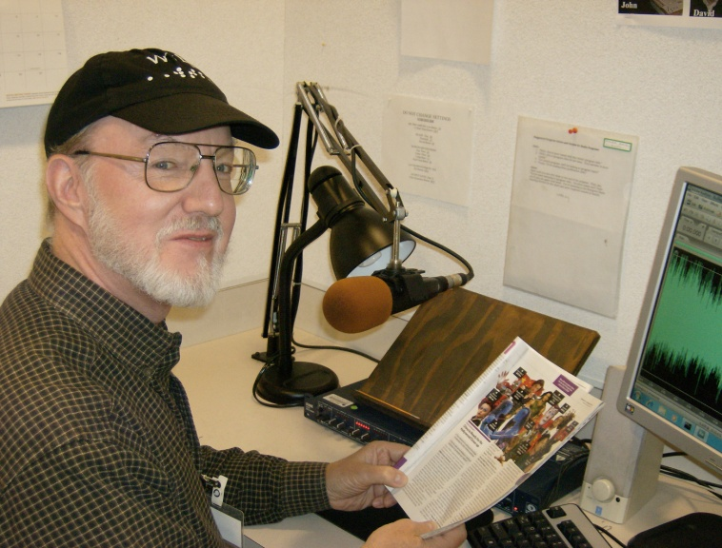
Ken Newman swears that he became an Evergreen Radio Reading Service volunteer before there was radio. Maybe it just seems that way. He started with us in 1979, reading the Saturday morning newspapers. Other than a short stint with the University of Washington Disabled Student Services office during a budget cutback at WTBBL in the early 1980s, he’s been with us ever since. He currently handles the “Business Report” program. He says it was early public-service commercials for “recording for the blind” by the Library of Congress on late-night TV that first generated his interest.
Ken was born and raised in Cleveland, Ohio. He lived outside Pittsburgh during his senior year of high school, and then attended Lafayette College in Pennsylvania. He worked in the merchant marine on the Great Lakes on ore boats for several years during and after college, and moved to Washington in 1974 to attend the University of Puget Sound’s law school (now the Seattle University School of Law).
Ken worked for Hewlett-Packard from 1979 until his retirement. He was a contract negotiator for most of that time, with customers across the U.S. and Canada. He and his wife, Shirley, live in Everett. Both are involved in other volunteer activities around the Puget Sound area. Ken is at Northwest Harvest’s Cherry Street Food Bank in Seattle two days a week, and helps with their special events and speakers bureau. He is also part of the team that handles audio services for the church they attend in Everett.
Shirley is also involved with activities at their church, serves on the board of their homeowners’ association, and works on the LiveArts Bothell arts festival. Ken helps with database and computer tasks for the festival, and takes on “beast of burden” duties during festival setup.
They both enjoy volksport, which is an international non-competitive walking activity. They have walked in events in the U.S. and Canada, and in September hit their goal of completing a 10 kilometer walk in every county in Washington State. It took them several years, but they say it was a great experience, and a terrific opportunity to see and learn about the different areas of this state.
They celebrated their 30th wedding anniversary this year with a cruise and tour to Alaska and the Yukon Territory.

Meet Our Staff: Sally Jo Hagen

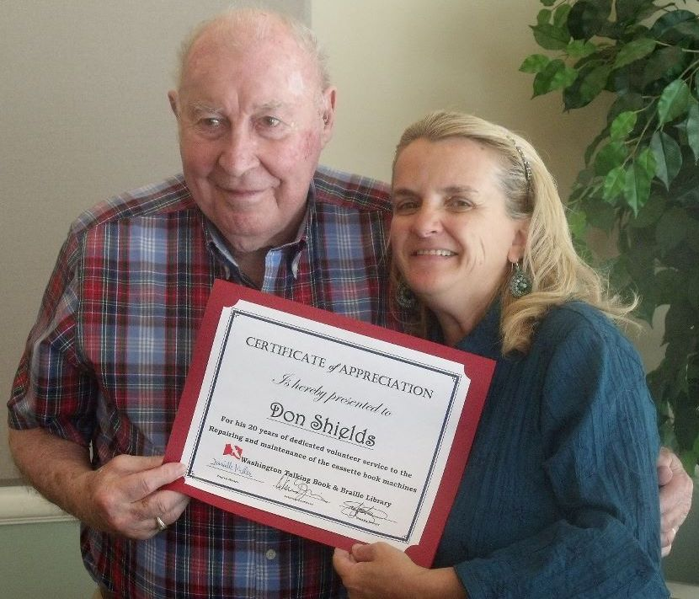
PHOTO: Sally Jo with retiring Lacey Talking Book Machine Repair Volunteer Don Shields.

I came to WTBBL in January 1997, by way of the Seattle Public Library (SPL), where I worked for 10 years. When the WTBBL Shipping Department Supervisor position was posted I applied and was the second choice. They filled the position with someone who, after one month in the job, decided there wasn’t enough customer interaction and returned to SPL. They offered me the position and have not been able to get rid of me since. Though it’s true that we don’t have a lot of customer contact, we do have a lot of in-person interaction with our volunteers who come in on a daily, weekly or monthly basis.
Working in the shipping department has turned out to be my dream job. Growing up, I would have never thought I would work in a library. I spent 10 years in retail, then one day a friend from high school called telling me of a position at SPL, and that led me here. I have a tremendous staff with Bonnie, Rick and Marah. They not only work great together and with other staff, but are wonderful with our widely diverse volunteer corps.
I grew up and still live in West Seattle. I got married 17 years ago to my Leonard, and we have our 16-year-old daughter Rose, who has gone to all the same schools I have. We are all big Seattle sports fans and believe that one year the Mariners and Seahawks will bring home their respective trophies.

Endowments: Gifts That Keep Giving by Carleen Jackson

Did you know that the Washington Talking Book & Braille Library is the beneficiary of two endowments? What is an endowment, you may ask?
An endowment is a fund established to generate revenue for an organization or special projects at an organization. An endowment fund is designed to function in perpetuity, making it possible to provide financial support over the long-term. The principal amount, which is not disbursed, is invested in a manner that creates a steady return; it is this return that is used to provide institutional support.
WTBBL benefits from an endowment with the Seattle Foundation, and a newly formed endowment with Spokane’s Inland Northwest Community Foundation. Both foundations manage and invest funds contributed to these endowments, and disburse returns on those investments to WTBBL each year. Those funds can then be used by WTBBL to support special projects and needs.
The Board of Trustees that oversees donor funds contributed to WTBBL recently decided to dedicate any unrestricted bequests received by WTBBL to the endowments, helping the endowments continue to grow. As the endowments grow, more funds will be available from each year’s investment returns for WTBBL’s needs far into the future.
Anyone can contribute directly to WTBBL’s endowments simply by contacting the Seattle Foundation or Inland Northwest Community Foundation and naming WTBBL as a beneficiary. Also, when making your estate plans, you can consider naming one of the WTBBL endowments as a beneficiary in your will.
For more information on bequests and endowments, contact Carleen Jackson at (360) 902-4126, or carleen.jackson@sos.wa.gov.

The foundations can be contacted at:

The Seattle Foundation
(206) 622-2294
www.seattlefoundation.org

Inland Northwest Community Foundation
(509) 624-2606
www.inwcf.org

Happy Holidays and Happy New Year from the Staff of WTBBL!

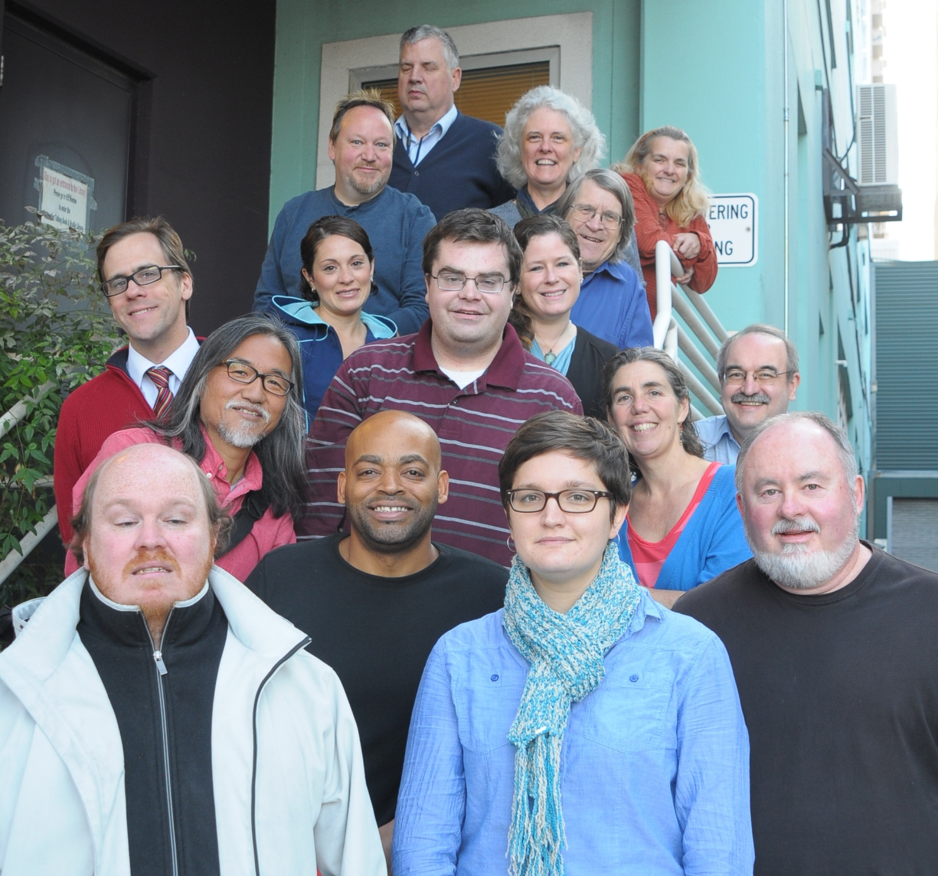

Bottom row left to right: Wes, Ricky, Marah, Steve; second row up: John, Theresa, Ed; third row up: David, Rocio, Tyler, Danielle; fourth row up: Gregg, Amy, Herrick, Sally Jo; top row: Alan. Not pictured: Eura, Bonnie and Rick.

