Washington Talking Book & Braille Library

A Program of the Washington State Library

and Office of Secretary of State

Reading Matters

Third Quarter, 2012

David Junius, Editor

A Message from Danielle Miller, Program Manager
I hope you have all enjoyed a wonderful summer and had a chance to escape into a great summer read. WTBBL was busy with our annual Summer Reading Program and welcoming our new Youth Services Librarian, Mandy Gonnsen. The theme this summer was “Dream Big! Read!” which got us all excited and dreaming about the growth of our program for children and teens. You can help us by spreading the word to kids, families and teachers (and don’t forget, children with reading disabilities are also eligible for WTBBL services).
The last two and a half years or so, our newsletter, Reading Matters, has only been available in electronic format via email and on our website. We recognize that it is difficult for many patrons to access the newsletter in a strictly electronic format. Beginning with the next issue, we will reintroduce Reading Matters in large print to be sent to all patrons. The print version will be slimmed down and will have a redesigned layout, and will continue to be available in text, audio, and web-braille at www.wtbbl.org. Reading Matters will frequently reference our new website for more detailed information on a particular topic in the issue. Our goal is to reach everyone using our service and get important service information and updates straight to your door.
Finally, as fall approaches, so does the statewide General Election. The position of Secretary of State oversees the Washington State Library and WTBBL, so we’ll be watching closely. If you need assistance with voting information, you can contact the state Elections Division at (800) 448-4881 or elections@sos.wa.gov.
I welcome your questions or comments about WTBBL and library service and you can reach me at (206) 615-1588 or danielle.miller@sos.wa.gov.

All Hail the BARD! by Tyler Kaye
Exciting changes are coming soon to BARD, the Braille and Audio Reading Download website!
Within the next few months, more than 12,000 books currently available on Web-Braille will transition over to the BARD collection, making the site a central stop for access to both downloadable braille and audio books. Web-Braille readers who do not yet have a BARD account should apply for one now at nlsbard.loc.gov. Click the “BARD Application Instructions” link and then select the “BARD application for individuals.” Once braille is added to BARD, new titles will be uploaded only there, and the existing Web-Braille site will shut down after a short grace period.
In response to popular demand, BARD is also adding a “My Wish List” function, which is a way to keep track of books to download at a later date, and a handy “My Previous Downloads” page. When searching for books, each summary listing will now have a link to detailed information similar to the NLS Union Catalog. The detailed listings contain links to all books by the same author or narrator, or in the same subject area or series.
For patrons of the NLS Music Section, thousands of braille and audio instructional materials will soon be posted to BARD. Music textbooks, sheet music, and method books will all be available as downloadable braille files. Audio downloads will include instructional guides by instrument and music-appreciation works.
If you haven’t logged on to BARD recently, take a moment to give the site another look and check back often. New books, as well as older titles converted from cassette, are added regularly, so there is always something to discover! Many library users who have applied for BARD access have never signed in at all, or have downloaded books only once.
We are always happy to offer downloading assistance and training, so please don’t hesitate to call (800) 542-0866 or email downloadsupport@sos.wa.gov anytime you need help.

New Braille and Talking Books from WTBBL by Theresa Connolly and Ed Godfrey
The volunteers and staff in the Audio Production Services Department and the Braille Department have been busy this year! We’ve added more than 30 new books to WTBBL’s collection and there are more than 50 currently in process.
Here is a list of books on subjects ranging from traveling and cooking to sports and adventure. You can download these books from our website at www.wtbbl.org or receive them on digital cartridge or in embossed braille by calling us at (206) 615-0400
or (800) 542-0866.

Talking Books

DBW 8298 The Year We Were Famous by Carole Estby Dagg.
This account of a walking trek from Mica, Washington, to New York City in 1896 is based on the true story of Helga Estby and her 17-year-old daughter. Narrated by Rachel Glass.

DBW 8235 The Circumference of Home: One Man’s Yearlong Quest for a Radically Local Life by Kurt Hoelting.
The author spent one year traveling within a 70-mile radius of his home and only on foot, bicycle, or kayak. Narrated by Barry Foy.

DBW 8274 Amy & Roger’s Epic Detour by Morgan Matson.
When 17-year-old Amy teams up with 19-year-old Roger so that she can get the family car from California to Connecticut, the pair ends up veering from Amy’s mother’s expedient itinerary. They venture off to see the sights. Along the way, they deal with serious issues troubling them, forge a friendship, and learn about the kindness of strangers. Narrated by Leighanne Law.

DBW 8260 Ichiro on Ichiro by Narumi Komatsu and Ichiro Suzuki.
Ichiro discusses his life, his love of baseball and becoming a star with the Seattle Mariners. Narrated by John Ogliore.

DBW 8221 Roy Morelli Steps Up to the Plate by Thatcher Heldring.
When eighth-grader Roy Morelli's divorced parents find out he is failing history class, they ban him from playing on his beloved all-star baseball team. Even worse, he winds up being tutored by his father’s new girlfriend and playing on a wimpy rec league. Narrated by Chris Snee.

DBW 8227 The Writer’s Portable Mentor: A Guide to Art, Craft and the Writing Life by Priscilla Long.
This book guides the reader in creating a writer’s life that is productive and rewarding. The emphasis is on establishing habits and acquiring skills. Many examples and exercises are included. Narrated by Andrea Lewis.

Braille: Adult Fiction

BRW 1325 Thousand Pieces of Gold: A Biographical Novel by Ruthanne Lum McCunn.
This biographical novel is based on the life of Polly Bemis, born Lalu Nathoy in China in 1853. Sold into slavery by her impoverished father, she changed hands until she ended up in a Central Idaho mining camp during the years of anti-Chinese racism. She eventually married Charlie Bemis and became a respected and beloved member of the community. Three volumes. 2004.

BRW 1327 Trial by Fire by J. A. Jance.
Former anchorwoman Ali Reynolds is the new media-relations officer for the sheriff in Sedona, Arizona. Her first case involves an amnesiac woman badly burned in an arson fire. Ali attempts to unravel the mystery with the help of a nun who advocates for unidentified hospital patients. Five volumes. 2009.

Braille: Adult Nonfiction

BRW 1333 Best Places Northwest Cookbook: Recipes from the Outstanding Restaurants and Inns of Washington, Oregon, and British Columbia by Cynthia C. Nims, Lori McKean, and Lara Ferroni.
The recipes in this book range from easy to advanced and feature local ingredients. The recipes are for breakfast, appetizers, soups, salads, breads, main dishes and desserts. The book has useful sidebars about ingredients and cooking techniques. Includes an index of ingredients and recipes, as well as a list of restaurants and inns that contributed recipes. Four volumes. 2009.

Adult Services Librarian Picks by Herrick Heitman
The National Library Service has recently issued three books set in the Northwest by popular authors.

Audio: Adult Fiction

DB 73064 Work Song by Ivan Doig.
In 1919, 10 years after leaving his teaching position in The Whistling Season (DB 63216), Morrie Morgan arrives by train in Butte, Montana, and moves into widow Grace Faraday’s boarding house. Although he would like to remain neutral, Morrie’s bookkeeping skills help the miners’ union against Anaconda Copper. 2010. Also available as a downloadable book from BARD: http://hdl.loc.gov/loc.nls/db.73064.

DB 73810 Betrayal of Trust [#20, J. P. Beaumont series] by Judith A. Jance.
Seattle investigator J.P. Beaumont and his wife Mel Soames are summoned to Olympia for a hush-hush case: The governor has discovered her husband’s grandson has a snuff video of a teenage girl on his phone. 2011. Also available as a downloadable book from BARD: http://hdl.loc.gov/loc.nls/db.73810.

DB 73841 Delicious [#1, Buchanan Family] by Susan Mallery.
Seattle. Cal Buchanan hires his ex-wife, top chef Penny Jackson, to turn around his family’s failing flagship restaurant. Penny still loves Cal, but she is pregnant from in-vitro fertilization. Meanwhile, Cal harbors family secrets. Explicit descriptions of sex and some strong language. 2006. Also available as a downloadable book from BARD: http://hdl.loc.gov/loc.nls/db.73841.

Greetings from the Youth Services Librarian! by Mandy Gonnsen
Our summer here at WTBBL was full of big dreams as we journeyed through the Youth Services Summer Reading Program, “Dream Big! Read!” With over 40 children and teen participants, we explored the wide world of dreams by making wishes, celebrating historical American dreams, imagining new ideas and dreams, telling scary (and not so scary) stories and nightmares, and learning how to make our own dreams come true!
Even if you weren’t able to join us on our summer reading journey, you can check out the “Dream Big! Read!” booklists for the entire summer at www.wtbbl.org/2012SummerReading.aspx. And if you read a book this summer (or during the school year) that you would like to review and share with other kids and teens, visit www.wtbbl.org/submit-book-reviews.aspx. With your permission, we’ll publish your review on our website and on our facebook page, www.facebook.com/WTBBL.
With the school year starting, we will be contacting school districts and schools throughout September and October to establish service and to review service settings for existing accounts. If you are a school administrator or teacher who needs an account, please contact me so we can get your students reading! Additionally, if you have students in your program who do not yet have an individual account, please contact me for an individual application. Students who have individual accounts have greater access to needed resources throughout school breaks, summer, and for reading outside school. Remember, only students with a reading disability need a signature from a doctor of medicine or osteopathy to qualify. Your school or local librarian can sign for all other qualifications.
Here at WTBBL, we have big plans for the school year for WTBBL kids & teens! Keep an eye on the Youth Services page of the WTBBL website for announcements, reading lists, and upcoming events!
Best wishes for a fun-filled school year!

Mandy Gonnsen, Youth Services Librarian
(206) 615-1253
mandy.gonnsen@sos.wa.gov

Youth Services Librarian Picks

Even though school has started, don’t forget to take 10 to 15 minutes a day to read! Both alone and with a family member, reading fun books not assigned in school can help children and teens practice their reading and literacy skills, as well as keep them interested in reading. Take advantage of some great new selections from NLS in both audio and braille and ease into the cooler fall days with a good book.

For Younger Readers:

DB 44738; BR 15177 Little Bear by Else Holmelund Minarik.
Four episodes about Little Bear in which he tries to persuade his mother to make him a winter outfit, makes himself some birthday soup, takes an imaginary trip to the moon, and finally goes to sleep as his mother tells him a story. For grades K-3. 1957. Read by John Horton. Reading time 13 minutes. Available as a downloadable book from BARD: http://hdl.loc.gov/loc.nls/db.44738

Braille:

BR 19041 Nini Lost and Found by Anita Lobel.
A pet cat named Nini slips out of the house and enjoys an outdoor adventure—until darkness falls. Large animal shapes and noises frighten her, but then Nini hears human voices calling her home. Print/Braille. For preschool-grade 2. 2010.

For Elementary & Middle Readers:

DB 74732; BR 19478 The Strange Case of Origami Yoda by Tom Angleberger.
Sixth-grader Tommy and his friends describe their interactions with a paper finger puppet of the Star Wars character Yoda — created, worn, and voiced by their weird classmate Dwight — as they try to figure out whether it can really predict the future. For grades 4-7. 2010. Read by Mark Delgado. Reading time 2 hours,11 minutes. Available as a downloadable book from BARD: http://hdl.loc.gov/loc.nls/db.74732

DB 72370; BR 19319 Zora and Me by Victoria Bond and T.R. Simon.
A fictionalized account of the childhood of African-American writer Zora Neale Hurston and her best friend Carrie in Eatonville, Florida, as they learn about life, death, truth, lies and pretending. Includes a brief biography of Hurston’s life. For grades 4-7. Coretta Scott King Award. 2010. Read by Channie Waites. Reading time 3 hours, 43 minutes. Available as a downloadable book from BARD:
http://hdl.loc.gov/loc.nls/db.72370

For Older Readers:

DB 74169 Beauty Queens by Libba Bray.
After their plane crashes and strands them on an island, the 50 beauty contestants for the Miss Teen Dream Pageant channel their talents into surviving. But the arrival of some hot reality television pirates adds new complications. Descriptions of sex and some strong language. For senior high and older readers. 2011. Read by Mare Trevathan. Reading time 11 hours, 56 minutes. Available as a downloadable book from BARD: http://hdl.loc.gov/loc.nls/db.74169

DB 73903; BR 18746 Shine by Lauren Myracle.
When gay teen Patrick Truman is brutally attacked and left for dead, the residents of Black Creek believe he is a victim of a hate crime. His friend Cat searches for who is responsible — and why. Violence and strong language. For senior high and older readers. 2011. Read by Jill Fox. Reading time 8 hours, 31 minutes. Available as a downloadable book from BARD: http://hdl.loc.gov/loc.nls/db.73903

Nonfiction:

DB 73961; BR 18755 Every Thing on It by Shel Silverstein.
A collection of more than 100 previously unpublished poems from the author of A Light in the Attic (BR 11934) and Where the Sidewalk Ends (BR 11502). Includes “The Lovetobutcants,” “Garlic Breath,” “Nasty School,” and “The Kid-Eating Land Shark.” For grades 2-4 and older readers. 2011. Read by Annie Wauters. Reading time 1 hour, 21 minutes. Available as a downloadable book from BARD: http://hdl.loc.gov/loc.nls/db.73961

DB 74427; BR 19482 Bootleg: Murder, Moonshine, and the Lawless Years of Prohibition by Karen Blumenthal.
The history and legacy of Prohibition, which began with passage of the 18th Amendment in 1920 and ended in 1933. Profiles Carrie Nation, the temperance movement’s first celebrity, and discusses the rise of bootleggers and gangsters such as Al Capone. For junior and senior high and older readers. 2011. Read by Bill Delaney. Reading time 4 hours, 10 minutes. Available as a downloadable book from BARD: http://hdl.loc.gov/loc.nls/db.74427

Volunteer Spotlight: Tanya Allison
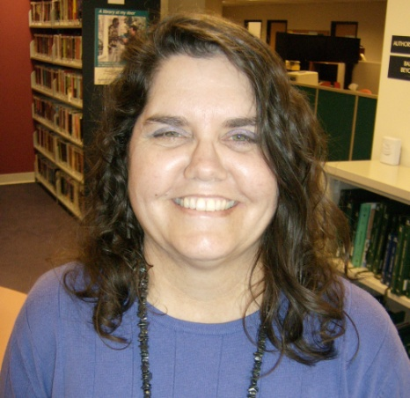
I was introduced to WTBBL through its braille transcription class. A friend showed me a bit about it and it seemed interesting, so I started the class with her. I have been transcribing for the library for the last year or two and finally have almost finished my first book, a cookbook. I have just started my latest assignment, a book on women’s suffrage in Washington State.
I use a program provided by the library that lets me use my laptop to enter the braille characters. I can’t imagine how much harder it must have been without the benefit of the backspace key! New rules have just been released, so there is always more to learn.
After the class was finished, I decided to try to volunteer as a reminder to keep up with the braille. I have settled into a split routine of reviewing audio books and reading book orders to readers advisor Alan.
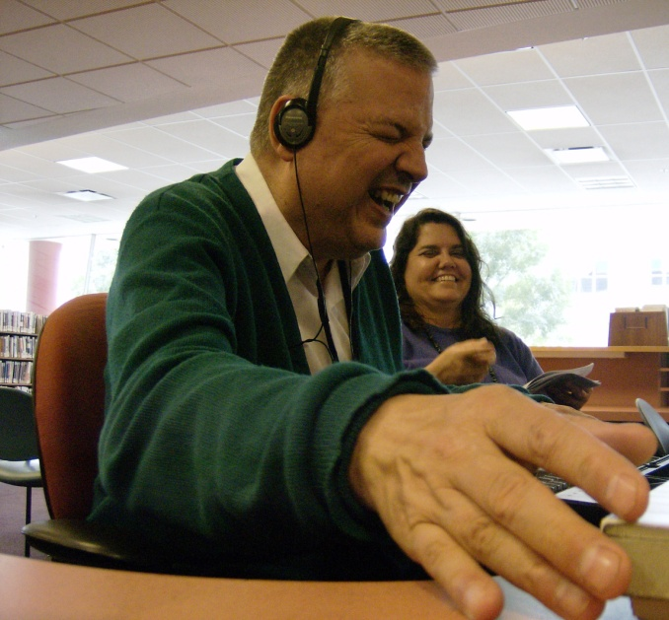
For the audio review, I follow along with the book and mark any errors or inconsistencies in the audio file. The other part of my day is reading aloud book orders to Alan. The orders come in on paper and I am reading notes and numbers to him. I am always impressed with how well he knows the patrons and the collection.
Sometimes there are still other tasks to do, most recently Alan and I were proofreading something for the Summer Reading Program and I made a few braille changes as well.
The staff at WTBBL is wonderful and great to work with. I look forward to coming in every week.

Staff Spotlight: Danielle Miller
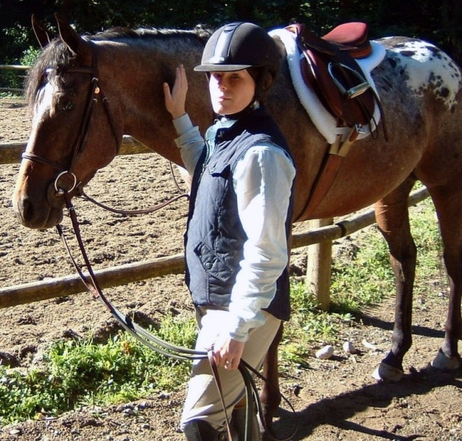
I like to think of myself as a native Washingtonian. My grandmother grew up on Queen Anne and went to the University of Washington, my mother lived with my grandmother on First Hill while my grandfather was in the war, and my parents met at Seattle University. But I don’t quite fit. I was born in Pasadena, California, but quickly moved to the Soviet Union when I was less than a year old, then to Windsor, England, then to Carson City, Nevada (which, even to a 5-year-old, paled in comparison to Windsor and Moscow).
We got to the Seattle area, near Redmond and Kirkland, in time for me to begin second grade. My cat rode on the airplane with me, my dog and hamster rode in the U-Haul with my father, and everyone made it safely. I’ve essentially lived in Seattle ever since but was able to get a few study abroad trips in while in high school and college.
In truth, I became a librarian because I couldn’t decide on anything else. I love languages, science, medicine, botany, zoology, medieval French history, math, photography and drawing, teaching…you get the picture. I also love helping people to help themselves. One day I discovered that as a librarian, you have the opportunity to help others and there are endless chances to learn a bit about thousands of things you never thought you would know about. For example, once at the public library, I had a gentleman ask me how he could “become the master of static.” That was a new one for me and one of the many examples of why this profession never gets old.
I can safely say that my work at WTBBL is the best job I’ve ever had and I’m constantly aware of how lucky I am to work with all of you good people. If I’m not at WTBBL, I hope I’m somewhere with my dog, good friends, and any other animals that can be wrangled up. Perhaps my biggest goal is to have a horse again someday…

Giving to WTBBL in 2012 by Carleen Jackson
Thanks to generous donors, foundations and bequests, WTBBL had an excellent fundraising year. The totals are all below for you to read, but the important thing is how those gifts are put to work to help our patrons.

Digital cartridges: Your gifts funded the purchase of $25,000 worth of digital cartridges. These cartridges allow WTBBL to download books directly from the National Library Service for use by patrons. The cartridges are also used to record books by local and regional authors not available from NLS. With the addition of these books, the library is kept fresh and up-to-date, and patrons have access to the latest books from both national and regional sources.

Outreach: The annual proceeds from WTBBL’s endowment with The Seattle Foundation have been dedicated to fund a children’s librarian and outreach position. By using the annual disbursement of interest from our endowment, we are also able to make sure we are contacting schools, medical facilities, families and other libraries to let them know of our services for children, youth and adults.

Radio service: Even though the Evergreen Radio Reading Service has been cut back, some donor funds were used to purchase technology that allows the service to continue and to access other similar services nationwide to augment local production.

Building our endowments: WTBBL has endowments with The Seattle Foundation and the Inland Northwest Community Foundation in Spokane. The board of directors overseeing the trust that accepts gifts for WTBBL decided this year to direct all unrestricted bequests to build our endowments. In FY 2012, we added an amazing $406,000 to our endowments. As our endowments grow, we will have “guaranteed” funds available to us each year from the interest on the endowments. Having those stable funds will allow us to plan and use them for critical needs over a longer time frame than we can with only annual giving. We are also very grateful to the nine donors this year who chose to remember WTBBL in their estate plans.

Thanks again to everyone who contributed to WTBBL this year. All gifts, small and large, are valued and are put to work to achieve our mission, that all may read.

Giving in Fiscal Year 2012:
Gifts from Individuals $62,000 (a 24% increase over FY 2011)
Memorials $4,700
Foundations $93,000 (a 48% increase over FY 2011)
Bequests $406,000 (allocated to build our endowments)

