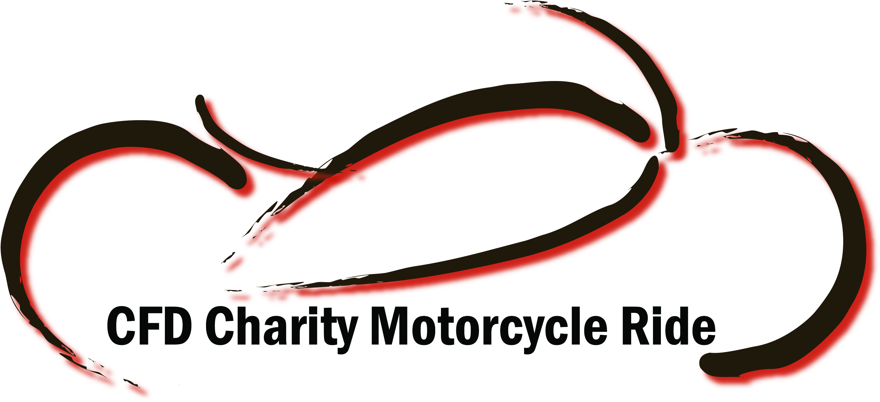
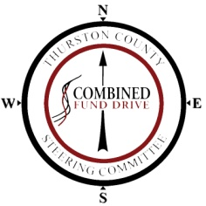
Charity Motorcycle Ride Registration
Benefitting the Combined Fund Drive Registered Charities

Event Date & Time: Saturday August 17, 2013 @ 8:00 am. (Last Bike out by 9:00 am)

Event Starting Location: Capital Campus North Diagonal Olympia WA

Questions??? For more information go to www.cfd.wa.gov or contact Dawn Sanquist at (360) 704-7143 or e-mail cfd@sos.wa.gov or cfd.tcsc@gmail.com

REGISTRATION FEES (All registration fees are non-refundable):
Registration after 7/31/13
Buffet & prize passport* included for each rider
Motorcycle Individual $35.00 |  | Motorcycle Rider w/ Passenger $50.00

Additional meals available for purchase at Lucky Eagle for $15.00 each.
T-shirts may be available for purchase at the event for $10.00 each.
*Prize drawings begin at 12pm. Must be present to win. Prize passports must be stamped at each pit stop to be eligible.

Waiver: In consideration of my entry in the CFD Charity Motorcycle Ride, I herby waive, release & discharge any and all claims for damages, injury and property damage, which I or my successors may have, or which may hereafter occur to me as a result of my participation in this event. This release is intended to discharge in advance the promoters, sponsors, and all municipalities and public entities (and their respective agents and employees) from and against any and all liability arising out of or connected in any way with my participation in the event. I understand the risks involved in participating in such an event. I herby agree to assume those risks and to release and hold harmless all of the persons or entities mentioned.

RIDER NAME (Must be 18 Years or Older):

Address: City: State: Zip:

Telephone ( ) E-mail:

Emergency Contact Name: Emergency Contact #: ( )

Signature of Rider: _______________________________________________ Date:

PASSENGER NAME: E-mail:

Emergency Contact Name: Emergency Contact #: ( )

Signature of Passenger: ___________________________________________ Date:
(or parent signature if passenger is under 18)

Please print and sign this form. Mail the completed registration form, with check (made payable to Combined Fund Drive), to: Combined Fund Drive; Attn: Dawn Sanquist: PO Box 40250; Olympia, WA 98504-0250.

